Church Schools

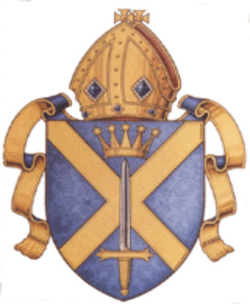
RE Scheme of Work
Autumn Term

Foundation Stage

Why are assemblies important in our Church School?
About this unit: For children attending voluntary aided Church of England schools, it is important that they have the opportunity to explore the rich
traditions of prayer and worship that characterize the worldwide community of Anglicans. In this unit, the children look at ways in which their school
is distinctive, beginning with assembly time.

Links with Early Learning Goals | Key vocabulary
Personal social and emotional development  Communication, language and literacy  Knowledge and understanding of the world | Assembly, God, Jesus, pray/prayer, worship, sing
Expectations
Most children will… | - Talk about special times in school when everyone meets together  - Talk about things they do in assembly  - Talk about Jesus as a special person for Christians
Some children will have progressed further and will… (Level 1) | - Recognise the main reason they come together with other children and teachers is for an ‘act of worship’

Learning objectives | Activities | Learning Outcomes | Notes/resources
To give children opportunities to:  - Know that assembly is an important time for their school to meet together.  - Begin to understand that assembly is a time to learn more about God, themselves and each other.  - Reflect on times when it is good to do things together with other people in school. | - Talk about times that are special for the children. Introduce assembly as a time that’s important for your school.  - Identify assembly time each day, and the place where you meet.  - Talk about what happens in assembly: singing songs, saying prayers, listening to stories, meeting visitors.  - Look at pictures of people praying. Talk about different times and places when prayers are said e.g. before dinner, at the end of the day.  - Make up own prayers and learn some simple prayers to say together.  - Discuss other places to worship God. If possible, visit a local church.  - Draw/make big pictures of assembly time. | Must children should be able to:  - Recognise when and where assembly takes place  - Begin to understand that there is a worship time in assembly  - Recognize that songs are sung about God and Jesus  - Recognise that prayer is a way for Christians to listen and talk to God | Big Book, My Christian Life, Brown and Seaman, Evans.  (see also My Jewish Life, My Muslim Life, My Sikh Life, My Hindu Life and My Buddhist Life)  Feeling Good: Songs of wonder and worship for fives and under Peter Churchill, National Society/Church House Publishing  Collection of children’s prayers e.g. Prayers for the Very Young, Sophie Piper, Lion

What is Harvest?
About this unit: In this unit children will learn about what happens at the school/Church Harvest Festival. They will learn about Harvest as a time when Christians bring gifts/food to the church as a way of sharing with others, and as recognition that God has given us much to share. Children will use the festival of Harvest as a stimulus to talk about ways in which they can share in the classroom.

Links to other curriculum areas | Key vocabulary
Personal, social and emotional development  Communication, language and literacy  Knowledge and understanding of the world | Harvest; festival; sharing; God; church service; church
Expectations
Most children will…(ELG) | - Talk about what happens in the church/school as a celebration of Harvest  - Talk about harvest as a time of sharing with others  - Talk about ways they have shared in the classroom
Some children will not have made so much progress and will: (Level 1) | - Recognise and talk about what happens at a Harvest Festival using some religious words and phrases  - Recognise Harvest Festival as a time of bringing food to share with others  - Talk about how they have shared with others and why sharing id important

Learning objectives | Activities | Learning Outcomes | Notes/resources
Pupils should learn:  - That there are opportunities to share our gifts in everyday life. | Listen to stories and poems with a sharing theme e.g.:  Oliver’s Fruit Salad  Ask each child to bring in a piece of fruit all of which an adult can cut up and mix together to create a colourful fruit salad which everyone can share.  Talk about the tasty dish that has been created by each sharing what has been brought.  Create a display by first giving the children a template of their own fruit which they can draw around on a piece of coloured paper. This can then be cut up into pieces by the child and put together with others to make an attractive collage of the fruit salad in a bowl.  and/or | Most children should be able to:  - Talk about different ways they have shared with others in the classroom. | Oliver’s Fruit Salad  by Vivian French & Alison Bartlett.  ISBN 0-340-70453-5  (Hodder Children’s Books)
 | Ask the children to bring in ingredients to make some small buns/biscuits to share with another class.
 | Organise a sharing week, where children can bring a favourite book to share with others
 | During Circle Time talk about less tangible things they have shared e.g. ways in which they have shared kindness, or time with others. A good story to use is The Lion Who Wanted to Love. |  | The Lion Who Wanted to Love by G. Andreae  ISBN 1 86039 913 4
- What happens at the school/church as a celebration at Harvest time  - That Harvest is a time for sharing gifts of fruit and food | Talk to the children about Harvest and about how many people see Harvest as a time of recognising that God has given so may good things in life that can be shared with others | - Talk about what happens at the school harvest festival  - Talk about bringing fruit and food to the church/school to share
Suggested assessment task:
Children can talk about ways in which they have shared with others in the class. They can draw a picture of a time when they have shared with someone else, and talk to their teacher about their picture.

Children can look at a picture of a church decorated for Harvest Festival, or photographs of the school hall decorated for Harvest Festival, and recall some details about what happens at a Harvest Festival service.

Idea for reflection:
Listen to a story about giving or sharing and then spend a short time quietly thinking about people who have shared something with you.

© Festival Matters
Foundation Stage

Who is Jesus?
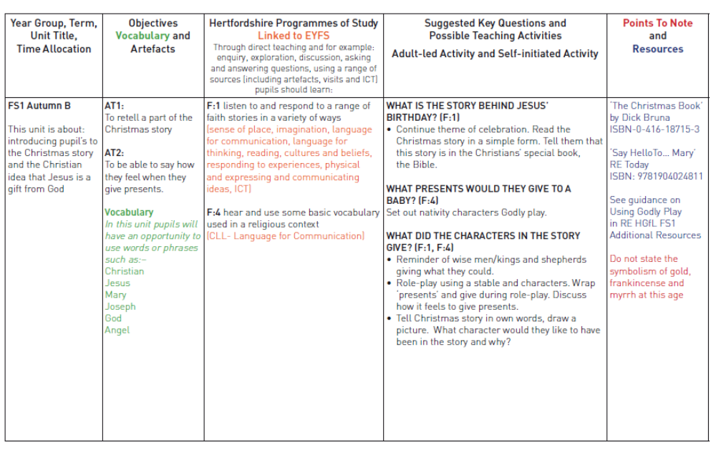

Spring Term
Why is our world important?
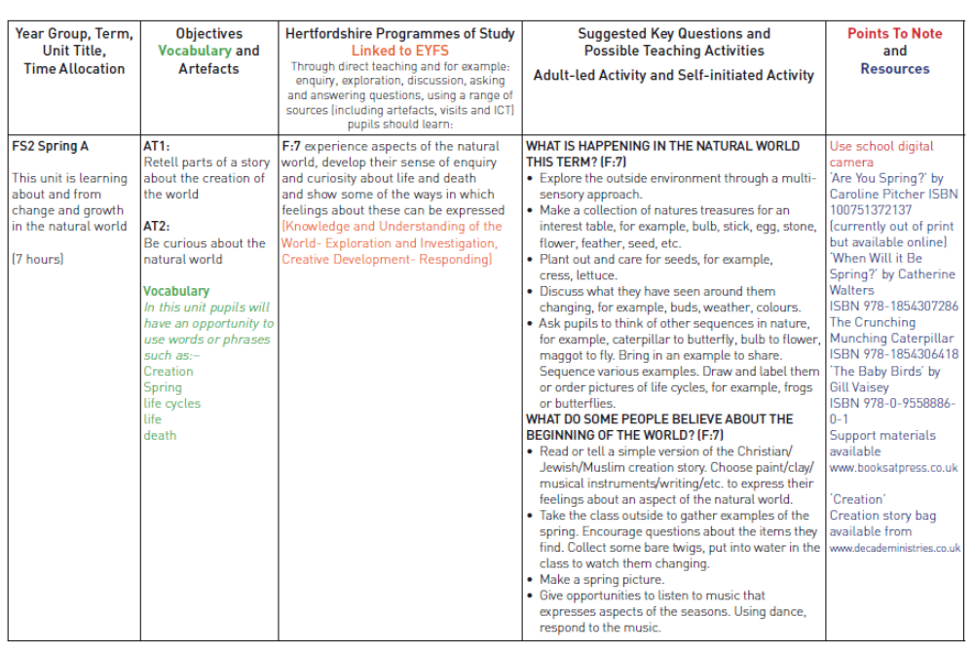

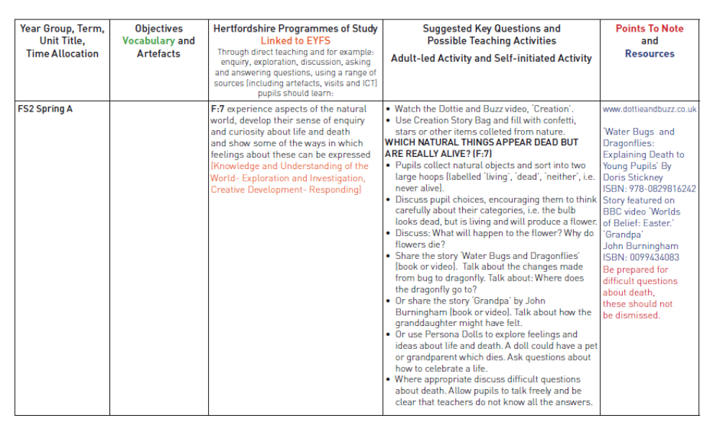

How do Christians remember Palm Sunday?
About this unit: In this unit pupils learn about the changes that happen in spring, about changes in mood, and about the joy of the first Palm Sunday.

Links to other curriculum areas | Key vocabulary
Knowledge and Understanding of the world  Personal, social and emotional development  Communication, language and literacy  Creative Development | In this unit children will have an opportunity to use words and phrases related to:  Church; Christians; Palm Cross; Palm Sunday
Expectations
Most children will…(Early Learning Goals) | - Be able to talk about changes that happen in spring  - Talk about times when they were happy or sad and describe their feelings  - Talk about some elements of the story of Jesus’ entry into Jerusalem  - Talk about where and when Christians receive a palm cross.
Some children will not have made so much progress and will: (Level 1) | - Be able to recognise changes that happen in spring  - Recognise and talk about their different feelings  - Recognise that the first Palm Sunday was a happy occasion  - Recall the story and recognise that people today have palm crosses

Learning objectives | Activities | Learning Outcomes | Notes/resources
Pupils should learn:  - About changes that occur in their natural environment in the Spring | Teaching Activities to highlight changes in the environment  - Take a walk in the school grounds to look for signs of Spring. Talk about the signs of new life. If possible repeat the walk two weeks later to reinforce this understanding.  - Create an Easter Garden, talking about the contents, colours etc of the garden.  - Show the children a collection of images on Easter cards that depict signs of new life, e.g. eggs, chicks, baby rabbits and spring flowers.  - Grow some bulbs/seeds – reminding the children that spring is the time of year when we see a lot of plant growth, trees etc ‘coming to life’.  - Make a display of ‘dead things’ that will come to life. On the walk collect a bare sad branch, but draw attention to small buds. | Most pupils should be able to:  - Talk about the changes they have observed.
- Think about times when they were happy or sad | Teaching Activities to identify and describe feelings  - Make happy faces into mobiles, use these to talk to the children about happy times in their life. When the tree ‘comes to life’, happy faces of children could be displayed on it. Make a class big book: ‘What Makes Us Happy?’  - By contrast children may wish to talk about times when they were sad. The teacher could highlight contrast of feelings through stories e.g. ‘The Gotcha Smile’; ‘Henry’s Song’; ‘So Much’. | - Talk about a time when they were happy or sad | The Gotcha Smile  By R. Mitchel  ISBN 1-86039-951-7 (Orchard)  So Much  By Trish Cooke  ISBN 0-7445-4396-7 (Walker)
- About the events of Palm Sunday and how these are remembered in the church today. | Teaching Activities to explore the story of Palm Sunday  - Hear the story of Palm Sunday. Through drama imagine what it might have been like to be a child in that crowd. Draw some pictures.  - Create a sound tape of the events of Palm Sunday  or  - Create a Joyful dance about the coming of Spring or the Palm Sunday procession.  or  - Create or use some ‘parade’ music.  - Make Palm leaves and decorate and use for parade. | - Talk about what happened on Palm Sunday | The Lion Storyteller Bible  by Bob Hartman  ISBN 0-7459-3607-5  The Lion First Bible (page 102),  by Pat Alexander  ISBN 0-7459-3849-3
Pupils should learn:  - How the events of Palm Sunday are remembered in church today. | Teaching Activities to explore how Palm Sunday is remembered today  - Look at and feel some Palm crosses; Tell the children that the cross is a special sign of Jesus and that people who go to Church on Palm Sunday receive a cross to help them remember Jesus and the story of Palm Sunday. | Most pupils should be able to:  - Talk about why Christians receive a Palm Cross on Palm Sunday
- Hear about what happens in the local church on Palm Sunday. Invite the local incumbent or a church member to explain what happens.

Suggested Assessment Task:
Children talk about a picture that shows the events of Palm Sunday.
Children recall and talk about a happy and/or sad time in their own experience

Idea for reflection:
Gather the children around the Easter garden display. Create a quiet, prayerful/reflective atmosphere. Play some quiet music. Light a candle. Lead the children into reflection and thanksgiving for all the signs of new life and for happy times shared together.

© Festival Matters
Summer Term What makes a place special?
Step1:  Key question | Either: use the key question suggested in the syllabus  Or: devise a key question of your own. Ensure that the key question fits with the themes  Make sure that the key question is sufficiently open to allow enquiry.  Explain where this unit/question fits into key stage planning e.g. how it builds on previous learning in RE; what other subject areas does it link to, if appropriate. | Key question:  What makes a place special?  Where does this fit into our Key Stage planning?  EYFS RE is at its best when there is an interplay between structured learning, creative play and speaking and listening. This outline plan for work on special places tries to show how this mix can be achieved, but it will always depend on what teachers do from their own ideas.
Step 2:  Key Learning objectives, learning outcomes  and assessment | Use the Key Learning objectives(see column 2 of the programme of study)  Select more detailed learning outcomes for the key questions (see the programme of study ideas on pages 21-28 in the syllabus). Ensure there is a balance of learning about and from religion.  Are the learning outcomes set at the appropriate level for your children do they need to be further differentiated?  Use the level descriptions on p. ?? to develop specific levelled “I can..” statements as appropriate to the age and ability of the pupils. These I can statements are found in the details of this unit.  These “I can” statements help you to integrate assessment for learning within the unit. There is then no necessity for an end of unit assessment within each unit. | Key learning objectives  Pupils should learn to:  - Respond to their work and their community with a range of feelings as appropriate (self esteem)  - Have a developing respect for their own cultures and beliefs, and for those of others  - Work as part of a group, taking turns and sharing fairly  - Use the imagination in relation to stories and play.  - Retell and sequence narratives through classroom talk and visual learning.  Learning outcomes  We are focusing on what makes a place special, so have selected and adapted the following learning outcomes. Children will be able to say ‘yes’ to some of these:  - I can take part in a stilling activity and use my imagination in silence  - I can draw a picture of my favourite place and talk about it  - I can choose from photos the ones I think are the saddest, happiest, calmest and freindliest places in a Church we visited  - I can identify or name some artefacts from a Church  - I can talk about some of the things Christians do when they go to church  - I can remember and tell someone three things that belong in a church  - I can tell someone about my own special places, and listen to someone talking about their special places  - I can ask a question about what makes a place special  - I can join a team to make a special place in our classroom, and play in the space  - I can join in a circle time conversation about churches and other special places  Assessment  These outcomes are turned into specific levelled I can statements within the detailed planning of the unit.
Step 3: Content | Select/adapt relevant content from column 5 of the programme of study to explore this key question. In general, depth is preferable to breadth. Other content can be used as appropriate to achieve the outcomes.  Pages21-28 of the syllabus are central to the understanding of this unit of work | Content  As we have chosen to focus on special places in this unit the content has been appropriately selected and adapted. Children will find out about:  - Each other’s special places, and reasons why they are special  - How silence and stillness can make us feel, and can help us imagine  - The place of worship in Christianity: the church  - Simple examples of the emotions worshippers might feel in church  - Stories that tell us about special places  - Through the activity of making a classroom ‘den’ or special place, children will be encouraged to ask good questions about what makes a place special.
Step 4: Teaching and learning activities | Develop active learning opportunities and investigations, using some engaging stimuli, to enable pupils to achieve the levelled outcomes. Don’t forget the skills you want pupils to develop. Make sure that the activities allow pupils to practise these skills. | Details of specific outcomes, teaching and learning activities and I can statements are found below.

Key questions:
What makes a place special? Do you have a special place? Where is it and why is it special for you?

Learning outcomes  Teaching should enable pupils to... | Teaching and Learning  Teachers can select from the following and adapt as appropriate, making sure that the learning outcomes are met and that pupils’ learning needs are addressed.  This material need not be taught as a whole unit but can be linked to work in other subject areas. | Levelled pupil outcomes:  so that pupils can say “I can...” to one or more of the statements below. | Notes
Understand that ‘special’ place has to do with how an individual feels about the place, and this may not be the same for everyone.  To think about the places that make them feel calm, happy, excited or friendly. | Our special places  - If I could go anywhere... Start off with a circle time that lets children express where they would love to go, and say why. Teachers or TAs might share a special place they have been to. Make them varied!  - Pupils listen to and report back to class on their partner’s special place.  - Ask children to think about the places in school they like best. Where is a good place in our school to be happy? To be sad? To be friendly? To be thoughtful? To be calm?  - If the children can agree on these places, then go and do something friendly in the friendliest place, something happy in the happiest place, something thoughtful in the thoughtful place, something calm in the clam place.  Using photos and working with older children  - Photograph some special places in and around school (Older pupils could do this, and bring their ideas to the 4-5 year olds). Create a PowerPoint and annotate with speech bubbles for pupils to say: Why are these places special? Are the all special to everyone, or just to some people? This can be a class or group activity.  - Incorporate photographs taken outside of school / at home into the PowerPoint.  - Pupils ask other members of the school community about their special places. | I can talk about a special place (L1).  I can say why a place is special to me (L1). | This unit develops a wide range of children’s skills including:  Language and literacy – new vocabulary, developing communication: speaking and listening skills.  Working with others  Thinking skills

Key questions:
What makes a place special? Can silence make your imagination work better?
Learning outcomes  Teaching should enable pupils to... | Teaching and Learning  Teachers can select from the following and adapt as appropriate, making sure that the learning outcomes are met and that pupils’ learning needs are addressed.  This material need not be taught as a whole unit but can be linked to work in other subject areas. | Levelled pupil outcomes:  so that pupils can say “I can...” to one or more of the statements below. | Notes
To use silence and stillness to deepen their imaginative learning in a simple way  Script: see the script on the last page of this unit. It is a starting point, tried and tested. | Guided visualization: using a stilling script  - Ask children to close their eyes and enjoy a journey in their imagination with you, to a special place. Use a script such as the one on the last page of this unit, to focus on taking pupils to their special place – what can they see, touch, hear? How do they feel?  - What memory of the special place do they want to keep? Follow this up with artwork to express their sense of place.  - Show and tell others in the school about their special places using the PowerPoint presentation and artwork | I can use the words ‘calm’, ‘happy’ ‘friendly’ and similar terms to describe how a place may have an atmosphere or feeling (L2).  I can share stillness and silence with other children, using my imagination (ELG). | Guided visualisation is an educational technique for imaginative learning. Teachers are encouraged to try it out, perhaps at first with a small group.

Key questions:
What makes a place special? Do Christian believers have a special place? What can we learn about it?

Learning outcomes  Teaching should enable pupils to... | Teaching and Learning  Teachers can select from the following and adapt as appropriate, making sure that the learning outcomes are met and that pupils’ learning needs are addressed.  This material need not be taught as a whole unit but can be linked to work in other subject areas. | Levelled pupil outcomes:  so that pupils can say “I can...” to one or more of the statements below. | Notes
That a Church is a sacred place for Christians  About some of the important features of the Church  About what a church feels like and looks like | Special religious places: Christianity (Part 1)  - Read a book about Church such as ‘My Christian Faith’ (Evans publishing), ‘Say Hello To Mary (RE Today, a whiteboard flashbook). Talk about the Church as a sacred place for Christians.  - Listen to some well known hymns or songs that may be sung in a Church. Listen carefully to hear the words, instruments (e.g. the organ - most churches will have one). Ask how the music makes us feel? Is it joyful? Peaceful? Is it about praising and thanking? What music makes the children feel excited, or calm?  Visit (or take a virtual tour of) a Church.  - Try to plan a walking visit to the local church. When you get there, do some activities – sing a song, make a little procession, sketch some flowers and some other beautiful things you see there. Make up questions, and find some answers. Talk about the feelings of the place – calm or exciting? Happy not sad? Thoughtful? Friendly?  - If you can’t visit, do a virtual tour. www.request.org.uk is a good place to start.  - Look at the outside of the Church: has it a steeple? A bell tower? When might you use the bells? Go inside; focus on the aisle, pews or chairs, symbols of the cross, water in the font. Discuss the symbolism of the candles (‘Jesus is the light of the world’ – what do Christians mean by that?) and the altar as a revered area within the church, a ‘special place in a special place’. Many statues, wall hangings, wooden carvings, stained glass depicting scenes from the Bible or a Saint.  - Explain why Christians may like to see these things. Is the Church light or dark inside?  - Tell a story at the church which has a special place as its subject. If you haven’t a better one, make up a story about a person Christened in the church, then married there 25 years later. | Recognise that a Church is a sacred place for Christians (L1)  Respond simply to the worship of Christians in hymns and songs (L1)  Talk about what we might see in a Church (L1).  Use correct vocabulary to recall the meanings of some artefacts from inside a church (L2) | If you are able to, take the class to visit a Church.  A virtual tour can be a good second best.  Use prepared photographs of objects within the Church to get the children ready for the visit.  Each pair of children can explore the church searching for objects to match their photographs.  Using ‘post-it’ notes they can give each object a name, or choose one word to describe it, and place the ‘post-it’ next to the object.

Key questions:
What makes a place special? How does the church make people feel?
Learning outcomes  Teaching should enable pupils to... | Teaching and Learning  Teachers can select from the following and adapt as appropriate, making sure that the learning outcomes are met and that pupils’ learning needs are addressed.  This material need not be taught as a whole unit but can be linked to work in other subject areas. | Levelled pupil outcomes:  so that pupils can say “I can...” to one or more of the statements below. | Notes
Why Christians come to a Church, what they do there and how they care for it  To reflect on what they have learnt | Special Religious Places: Christianity (Part 2)  How do Christians use the church?  How do they make it a special place?  - Discuss with the children how the Church congregation will attend a church service often on a Sunday and listen to a reading at the Lectern (taken from the Bible). A Priest / Vicar / Minister will preach a sermon, to explain the reading. Members of the church might sing, pray, listen and talk. They share some bread and wine, which are reminders of Jesus.  - Tell the children that Christians believe that Jesus’ presence is with them: ask questions of wonder: I wonder what that means? I wonder how they can tell Jesus is with them? I wonder how they feel?  - The Church can be seen as a kind of family: everyone helps each other and looks after the church. Some may decorate the church with flowers, some clean the church, some help other people when they have hard times.  - To music, ask the children to make rings of three, four or five people by holding hands, and marching or skipping round. These are like our families. Ask them to join all the rings together and march or skip round in a big circle of the whole class. This is a bit like the church: people joining together. | Suggest simply why people might like to go to the Church.  Talk about what makes church a special place for Christians (L1)  Talk about why people would volunteer to look after the Church, responding sensitively to ideas about the holiness of a place (L2) | Children can draw or sketch the object hey like best from the church visit or virtual tour.  This is a way of them bringing the special object back to school with them.

Key questions:
What makes a place special? Stories of special places: What do we like about them?
Learning outcomes  Teaching should enable pupils to... | Teaching and Learning  Teachers can select from the following and adapt as appropriate, making sure that the learning outcomes are met and that pupils’ learning needs are addressed.  This material need not be taught as a whole unit but can be linked to work in other subject areas. | Levelled pupil outcomes:  so that pupils can say “I can...” to one or more of the statements below. | Notes
To listen to stories of special places and enjoy them;  To think about a special place in a story. | Special places in stories: what do we like?  - Read a story with the class that is about a special place. A good example is ‘The Big, Big Sea’ by Martin Waddell, illustrated by Jenny Eachus. It is a lovely story of mother and daughter on the beach.  - This story is about how the beach is a special place for the girl in the book. The occasion, her mum’s company and the magical view are what makes it special.  - Ask children if they know other stories about special places, and if they like them.  - Talk about our own special places again, and ask children what makes the places they love most special. What if their ‘special place’ had a book made about it? What picture would they put in, and why?  - Alternatives to this book include: “Enchantment in the Garden” by Shirley Hughes (Red Fox, 1996). Another alternative would be to show children a clip from a movie where a special place can be seen and explored: for example, the bedroom in Toy Story or the bedroom in Monsters Inc (that one can be scary – use a clip near the end). | I can talk about a special place in a story.  I can use the words ‘exciting’ ‘magical’ or ‘thrilling’ and similar terms to describe how a place may have an atmosphere or feeling. | Martin Waddell’s book is not essential for this: there are many examples. This one is published by Walker books, 1994.  The teaching order in these lessons is planned to place the church visit early in the unit. It makes it easier to connect to the later activities, where the focus is on children’s own sense of ‘special places’

Key questions:
What makes a place special?
What kind of special place can we make in a team in our classroom?
Learning outcomes  Teaching should enable pupils to... | Teaching and Learning  Teachers can select from the following and adapt as appropriate, making sure that the learning outcomes are met and that pupils’ learning needs are addressed.  This material need not be taught as a whole unit but can be linked to work in other subject areas. | Levelled pupil outcomes:  so that pupils can say “I can...” to one or more of the statements below. | Notes
To play and work together with other children  To use their imagination in creating a special place and playing in it.  To think about their special place and the Church. | Making our own special places: playing around with clothes pegs, sheets and chairs.  - Say to the group, ‘Let’s make some special places in the classroom. How shall we make them?’ Listen to all the ideas, and list them.  - You might feed in suggestions: special places made in teams, like dens or little houses. What are they for? Places to look at special things, to meet people, to share, to be friendly, to be calm.  - Give each group of 3-6 children some sheets or curtain materials, and clothes pegs. They will need some sting and some furniture to move and build from. They can create a den, a shelter or a little house in a part of the classroom. They can think up and play out some special activities or things to look at. It is often good to talk about this one day, and do it the next morning – so that children can bring some things from home. This is a very exciting activity – be prepared to calm things down several times.  - Encourage children to enjoy playing in the space they have made special, and visit each other’s special places.  - Tell some stories of special places in the ‘dens’; the children have made.  - Ask children: is your special place like the church at all? Can you think of any ways it is similar?  - Special places don’t last for ever. It will be good if the children carefully take their ‘den’ apart and put things away. | I can play together with other children and learn from the play.  I can talk about what made our ‘den’ special (L1)  I can respond sensitively to questions about special places, including religious ones (L2) | There are always safety issues about this kind of team play: good teaching will be alert to these, and plan to avoid them, then cope with the unexpected!  Play matters: it is easy to think we have no time for this kind of activity, but learning is deepened and made personal through play for 4-5 year olds. Worth giving time!

Key questions:
What makes a place special?
What big thoughts and questions do we have about special places?
Learning outcomes  Teaching should enable pupils to... | Teaching and Learning  Teachers can select from the following and adapt as appropriate, making sure that the learning outcomes are met and that pupils’ learning needs are addressed.  This material need not be taught as a whole unit but can be linked to work in other subject areas. | Levelled pupil outcomes:  so that pupils can say “I can...” to one or more of the statements below. | Notes
To make some pictures of special places  To talk about the special places in relation to the church. | Making pictures  - Give children time to enjoy some drawing and picture making. They might choose between drawing three pictures in a 3- piece frame – one of the church, one of their own special place and one of their friend’s special place, or making one larger art work that shows several things about their own special place.  - Give them some good quality materials to work with – perhaps they can incorporate a photo from the visit or virtual tour.  - When these pieces of work are finished, use circle time to share and review them.  - Spend some class time talking about the unit: remind the children of the stilling story, the church visit, the den-making play time, the story of ‘The Big, Big Sea’ and other things you did.  Questions of wonder:  Ask these questions giving pauses and time for answers to develop. Receive all the answers with thanks, but no comment.  - What makes a place special?  - Where is your special place?  - What do you like to do there? How do you feel?  - What do Christians like to do in their special place, the church? How might they feel?  - Does everyone have the same special place?  - Why is a religious building a special place for some people?  - Are some places special because of what happens there?  - Are some places special to lots of people?  - Do you think our local church (or the virtual visit church we saw) is a special place? Why / why not? | I can make pictures to show what I have learned about special places  I can talk thoughtfully about what makes a place special (L1)  I can identify why a church is a special place for a Christian (L2). | Some schools concentrate their RE unit into a short space of time – not one lesson a week, but a week’s work in half a term. In this unit, would your children learn better if you did this?  This unit of course has many links with the ELG areas, especially K&U of the world and creative development.  SEAL programmes connect to the work as well.

Key questions:
What makes a place special? What have we learned about special places?
Learning outcomes  Teaching should enable pupils to... | Teaching and Learning  Teachers can select from the following and adapt as appropriate, making sure that the learning outcomes are met and that pupils’ learning needs are addressed.  This material need not be taught as a whole unit but can be linked to work in other subject areas. | Levelled pupil outcomes:  so that pupils can say “I can...” to one or more of the statements below. | Notes
To collect the class’s main ideas about special places;  To think about what they have learnt  To present information to suggest why only certain places are special and / or sacred. | Our special places are all different.  - Lots of people have a special place. Different religions: what are their special places?  - Prepare a presentation or an assembly to share with school.  - Children could work in small groups each looking at different aspects of the sacred place they have visited.  - They could work in the character of a believer and make important resources / objects similar to the ones they have noticed on the virtual tour.  - Listen to reflective music whilst working.  - What would you see through the keyhole in a sacred place?  - Give the children a large (A3) keyhole template and ask the children to look through the keyhole into the sacred place and draw and label what they expect to see.  - Talk about the completed keyholes in circle time asking children to identify and describe what they have illustrated and labelled and why. | Talk about special places from different religions (L1)  Suggest why certain places are sacred and to whom (L2)  Respond sensitively to the learning (L2) | If a visit has been undertaken an activity could be to write letters of thanks to whoever met and guided the pupils round.

Resources
Websites: Useful websites:
- www.ngfl-cymru.org.uk is the Welsh Virtual Teacher Centre. It contains some good materials for teaching to this age group.
- Christian artefacts (images): www.strath.ac.uk/Departments/SocialStudies/RE/Database/Graphics/Artefacts/CAfacts.html
- RE:Quest: www.request.org.uk An engaging website with a very wide range of materials.
- The National Society supports RE with some books and this website on ‘Encountering Christianity’ www.encounterchristianity.co.uk Particularly relevant to this unit are the books called ‘Encounter Christianity in Journeys’ and ‘Encounter Christianity in Creation.’
- A selection of images of Christian churches, interiors and exteriors, is useful, the more local the better.
- The National Association of Teachers of RE (NATRE) hosts a web gallery of children’s art work:: www.natre.org.uk/spiritedarts
- www.request.org.uk/infants (Milestones in Family Life – a video loop on Baptism
- www.dottieandbuzz.co.uk/prog3/index.html (video clips on many Christian topics)
- The BBC’s Learning Zone Broadband Clips Library provides short clips relevant to this unit: www.bbc.co.uk/learningzone/clips
- Sacred Space provides inspiration, case studies and guidance to help you make learning outside the classroom work really well for RE: www.refuel.org.uk/sacred-space
- The Learning Outside the Classroom (LOtC) website is a useful resource for professionals: www.lotc.org.uk

Virtual Tours:
- Christianity: www.educhurch.co.uk
- For further links visit www.reonline.org.uk (select juniors on right side of web page and click on tours)
- If access to internet is unavailable the DVD ‘Worship’ produced by REonline is a useful tool to explore places of worship.

Print resources
- Say Hello To... (RE Today). This set of 6 interactive whiteboard flashbooks and accompanying resources can be networked to the schools computers. ‘Mary’s Story’ is the relevant one in this unit.
- Places of Worship Photo packs (Folens)
- Developing Primary RE: Special Places, Worship, ed. Joyce Mackley, from RE today
- Sacred Stories(Exploring a Theme), ed. Joyce Mackley, RE Today, ISBN 978-1-905893-11-9: http://shop.retoday.org.uk
- Special People (Exploring a Theme) ed. Joyce Mackley, RE Today: http://shop.retoday.org.uk

Video and audio
- DVD plus packs (BBC shop) including places of worship and world faiths.
- Soundhealth supply a range of music designed to enhance specific activities (relaxation, thinking, calmness) visit www.abtmusic.com

Artefacts for Christianity are available to purchase from:
- Articles of Faith (Tel: 0161 763 6232)
- Religion in Evidence (Freephone 0800 137525)]

Audio and video resources
- Miracle Maker Warner Home video / DVD – an almost indispensable help to teaching about Jesus, this 90 minute animated life of Jesus is supported by teaching ideas from www.biblesociety.org.uk/miraclemaker
- Pathways of Belief videos and teachers notes. BBC

A sample ‘stilling and thinking’ script
Learning to be still: Ask children to lie on a carpet, perhaps with a cushion for this way of using the imagination. It won’t work if they have just done energetic PE, or had an argument: choose your occasion well.

Speak to them from this script, slowly, and allowing pauses for their imaginations to work.

“Children, in the next few minutes we are going to use a special way of imagining. I’d like to ask you first to close your eyes. Have a little peep if you want to, then close them again, and listen to the quietness in the room for a moment. Some noises may come along, but you can just stay quiet and still, like all the other children. Listen to the sound of your breathing. Don’t breathe fast or slow, just normally, but feel the air coming in and out of your nose.

Imagine that you are breathing out your worries and breathing in calmness: out go the worries, in comes the calm. Worries out, calm in.”

Pause (make pauses of perhaps 20 seconds between the next three instructions. You may need to time these pauses – teachers often speak too fast)

“Now I’m going to ask you to focus on some parts of your body. Start by focusing on your toes. How do they feel? Wiggle your toes about, and then let them be still and relaxed.

Next do the same with the muscles in your legs – tighten the muscles, and then let them relax.

Next think about your fingers: make them into little fists, and then let them go floppy and relaxed.

Now I want you to imagine that you are somewhere very special, your favourite place. Everyoen has a favourite place, but it is different for each person: where is yours? Imagine you are on your own there. You are feeling very happy, and very calm. You look around. When you are in your favourite place, what can you see? What is there to look at? In your imagination, look around and notice all the things that make it your favourite place.”

Longer pause: maybe 45 seconds

“Notice the colours. Notice the shapes. Notice the sounds and the silence. Enjoy being in your imaginary special place. In a moment, we are going to stop this imagining, but before you ‘come back’ to our classroom, think about one picture you would like to bring back from your special place. If you had a camera, what picture would you take, to keep? Imagine your picture. Imagine clicking your camera to take the picture.

When you are ready, wriggle your fingers and toes again, and then you can open your eyes. Have a little stretch, Thank you.”
Tell the children that they have done well, and some much older children don’t do as well as them in this activity. Ask them to tell a partner and you about their imaginary places. Allow all the time they need.

Lat Blaylock, RE Today, Luton, Central Bedfordshire and Bedford Borough / 2011

Foundation Stage
What can we learn about God from listening to Bible stories?
About this unit: Children are introduced to two well known Old Testament figures, David and Joseph. These religious stories explore feelings and experiences familiar to the children and they discover the importance of God to the people in these stories.

Links with Early Learning Goals | Key vocabulary
Personal social and emotional development  Communication, language and literacy  Knowledge and understanding of the world | David and Goliath  Shepherd, brave, afraid, God, protect | Joseph  Brother, jealous, dream
Expectations
Most children will… | - Recall elements of the story of David and the story of Joseph.  - Begin to talk about God being important to the people in these stories.
Some children will have progressed further and will… (Level 1) | - Recall the stories and talk about them.  - Talk about their own experiences and feelings  - Respond simply to parts of the story they like/find interesting/puzzling.

Learning objectives | Activities | Learning Outcomes | Notes/resources
To give children opportunities to:  - Know stories from the Old Testament  - Begin to understand that God is important for some people.  - Begin to understand that Christians believe that God can help them when they are afraid  - Begin to understand what is right and what is wrong  - Reflect on feelings e.g. feeling small, being brave, feeling afraid, jealous. | Use the Story Candle ritual when telling these stories. A simple retelling of these stories is most appropriate e.g. from a children’s picture Bible. See alternative suggestion in resources section.  David and Goliath  - Make a collection of big and little things  - Sequence the story using pictures  - Dramatise the story  - Discuss issues raised by story e.g. bullying  Joseph  - Make a collection of coloured fabrics; count and name the colours.  - Find Egypt on a simple world map. Talk about making right and wrong choices and other issues raised in the story e.g. jealousy, hurting others, saying sorry  - Listen to songs from ‘Joseph and his Technicolour Dreamcoat’  - Draw and write about dreams | Most children should be able to:  - Recall elements of the Bible stories they have heard.  - Begin to understand that God is important for some people. | Story candle (see Our Story Candle)  Solihull Metropolitan Borough Council Handbook for RE in the Foundation Stage (Retelling of the stories with questions for discussion: David and Goliath pp22-25 and Joseph pp 28 – 32)  Children’s picture Bible (e.g. The Lion Storyteller Bible or the Lion First Bible)  Bible refs for teacher preparation:  David: 1 Samuel 17  Joseph: Genesis 37 – 47  Recording of ‘Joseph and his Technicolour Dreamcoat’  Colourful fabric/patchwork quilt
Suggested assessment tasks
Ask the children to make a picture to show something that frightens them, and something that makes them feel brave.
Draw a picture of the story and talk about it.
Use a picture of the David story or the Joseph story and use ‘feeling’ words e.g. David was brave, the people were frightened of Goliath, Joseph’s brothers hated him, were jealous of him…

