Church Schools
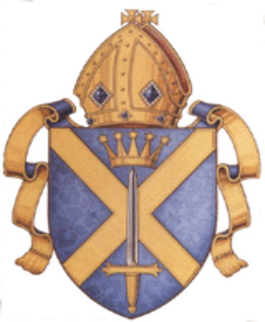
RE Scheme of Work

KS 2 Year 5
Autumn Term
Buddhism – Who is the Buddha?

Lesson objectives and success criteria | Main activities | Resources | Assessment
WALT: think about who our heroes are and why.  I can say who my hero is and think about their physical attributes and human qualities. | - Introduce the topic of Buddhism.  - Buddhists have don’t have a God but their founder is the Buddha (remind no special powers, a man not a God!)  - Who is your hero and why? Think about physical attributes and human qualities.  - Do they influence you in any way? Discuss how a hero might influence you in the way that you dress, what you watch or how you behave.  - Tell children that the Buddha influences Buddhists and that they follow his teachings, and that this is what they will be learning about over the next few weeks.  - Get the children to make a drawing of their hero, writing words around the outside for physical attributes and words on the inside for human qualities.  - Plenary: compare heroes – who influences you compared with your partner and why? |  | Sub question: Why do we have heroes?  AT2 L3 – I can compare some of the things that influence me with those that influence other people.  AT2 L4 – I can ask questions about who we are and where we belong, and suggest answers that refer to people who have inspired and influenced myself and others.
WALT: understand why the Buddha’s choices are important.  I can talk about whether or not I think the Buddha should have left the palace and give reasons for my opinions. | - Who can remember who the Buddha was? Talk about how he is not alive today but that Buddhists still follow his teachings.  - Talk about how the Buddha had many different qualities. Use images of the Buddha and the Buddha statues (pass around) and get the children to discuss how these might inspire Buddhists.  - Tell the children about the first part of the Buddha’s life – slides 1 and 2 on the powerpoint in staff resources.  - Discuss the story – why did these 3 things make the Buddha want to leave the palace?  - Would you have left the palace? Conscience alley with one person being the Buddha and sides giving reasons for and against the Buddha leaving the palace.  - Children to write in their books the reasons for and against the Buddha leaving the palace. | Power point on the life of the Buddha in Staff Resources.  Statues and pictures of the Buddha | Sub question: What can Buddhists learn from the Buddha’s life?  AT1 L3 – I can describe what a Buddhist might learn from this story.  AT2 L3 – I can compare some of the things that influence me with those that influence other people.  AT1 L4 – I can describe and explain why the Buddha made the choices that he did.  AT2 L4 – I can ask questions about the moral decisions I and other people make, and suggest what might happen as a result of different decisions.
WALT: understand why the Eight-Fold path is important.  I can discuss the different elements of the Eight-Fold path and think about how they help Buddhists to live their lives.  I can design my own set of rules on a way to live a good life. | - Recap first part of the story from last week. What happened?  - Read the rest of the story and discuss. What do you think the Eight-Fold path is? Display the Eight-Fold path and discuss certain ones for example what do you think Right Speech is?  - Why do you think Buddhists today still follow this as a guide for their lives?  - What rules would you make as a guide to living a good life? Discuss  - Children to design posters with rules on them as a way to live a good life. | Power point from staff resources | Sub question: What can Buddhists learn from the Buddha’s life?  AT1 L3 – I can describe what a believer might learn from a religious story.  AT1 L4 – I can express religious beliefs in a range of styles and words used by believers and suggest what they mean.  AT2 L4 – I can ask questions about the moral decisions I and other people make, and suggest what might happen as a result of different decisions.
WALT: explore what enlightenment means.  I can understand how enlightenment is a state of inner peace.  I can create a newspaper report in which I interview the Buddha and try to understand how he was feeling when he reached enlightenment | - What was the Eight-Fold path? Recap  - Discuss how the Eight-Fold path is a way to become what Buddhists call enlightened.  - Show the children the symbol of Buddhism – why do you think it is an eight spoke wheel?  - What do you think enlightenment is?  - Tell the children it is a state of inner peace which Buddhists believe they can reach by following the Eight-Fold path, including meditation.  - Put on some calming music and get the children to sit in silence for two minutes and think about something important – discuss the experience.  - Children to do a newspaper report – H/A to interview the Buddha after his enlightenment, L/A to write about what happened during the lead up to his enlightenment. | Eight-spoke wheel of Buddhism | Sub question: What can Buddhists learn from the Buddha’s life?  AT1 L4 – I can express religious beliefs in a range of styles and words used by believers and suggest what they mean.  AT2 L4 – I can ask questions about the moral decisions I and other people make, and suggest what might happen as a result of different decisions.
WALT: explore how Buddhists follow the Buddha’s teachings.  I can talk about what the Dalai Lama did and how he follows the Buddha’s teachings.  I can create my own prayer flags and explain what they symbolise and why. | - Do you know any famous Buddhists who follow the Buddha’s teaching?  - Focus on the Dalai Lama – talk about how Dalai Lama is a name one person takes on and he is the spiritual leader of a part of Buddhism from Tibet. Can you think of anyone else who is a religious leader (compare to Pope?)  - Dalai Lama is a leader and a teacher, he used to lead Tibet but he got exiled and lives in Indian with other Tibetan Buddhists. Inspirational for his teachings and practice – peaceful even in exile.  - He once said ‘If you want others to be happy, practise compassion. If you want to be happy, practise compassion.’ Discuss what this means.  - Show the Tibetan prayer flags and display – discuss how they are flown to represent peace, freedom, compassion, strength and wisdom.  - Children to design their own prayer flags thinking about why they are flown. H/A to explain their design. | Pictures of the Dalai Lama  Tibetan prayer flags | Sub question: Who is the Dalai Lama?  AT1 L3 – I can use religious words to describe some of the different ways in which people show their beliefs.  AT2 L4 – I can ask questions about who we are and where we belong, and suggest answers that refer to people who have inspired and influenced myself and others.  AT2 L4 – I can ask questions about the moral decisions I and other people make, and suggest what might happen as a result of different decisions.
WALT: discuss what the most important parts of a religion are.  I can compare Buddhism to Christianity thinking about how the teachings and beliefs are similar and how they differ.  I can say which parts of Buddhism are the most important and give reasons why. | - What have you learnt about Buddhism?  - Can you draw any links with Christianity? Think about the teachings of the Buddha and the teachings of Jesus, the life of the Buddha, Ten Commandments etc.  - Discuss any differences that the children may have found and talk about how many religions have similarities.  - Children to work in pairs with a target board. They have a group of words to do with Buddhism and have to put 1 in the middle for the most important, 3 on the next ring for really important, 5 that matter a lot on the next ring, 7 that matter on the next ring and ones that don’t matter on the outside. Children then swap with another pair and explain their reasoning for where they placed their cards. | Target boards (RE cupboard)  Cards with words to do with Buddhism on them. | Sub question: How do Christianity and Buddhism compare?  AT1 L3 – I can describe some of the things that are the same and different for religious people.  AT1 L4 – I can make links between the beliefs of different religious groups and show how they are connected to believer’s lives.

What role does journeying play within the Christmas story?
About this unit: In this unit, children will learn about the journeys connected with the Christmas story. They will reflect upon the journeys of people today who are fleeing from persecution.

WALT and Success Criteria | Main activities | Resources | Assessment
WALT: explore how difficult Mary and Joseph’s journey to Bethlehem was.  I can listen to the story of Mary and Joseph’s journey to Bethlehem and discuss what it would have been like.  I can pretend I am Mary or Joseph and write a diary entry about my journey to Bethlehem, focusing on my thoughts and feelings. | - Discuss the journeys that children have made. How did you prepare? How did you travel? How did it feel? Have you ever had to move from one place to another? How did that make you feel?  - Read an extract of the Christmas Bible story in which Mary and Joseph travel to Bethlehem.  - How do you think it would have felt? How long might it of taken them? Do you think they were brave doing this long journey when Mary was pregnant? Discuss how long and hard the journey would have been and why. Would you have made the journey? Show children artwork depicting this scene to show how hard the journey was.  - Suggested task: write a diary entry from the point of view of Mary or Joseph about the journey to Bethlehem. | Story of Mary and Joseph’s journey to Bethlehem.  Artwork of their journey (some in RE cupboard) | Sub question: Was the journey to Bethlehem difficult?  AT1 (L3) – ‘I can describe what a believer (religious person) might learn from a religious story.’  AT2 (L3) – ‘I can link things that are important to me and other people with the way I think and behave.’
WALT: explore the journey of the Three Wise Men.  I can listen to the story of the Three Wise Men and a poem about their journey and discuss how I think they felt.  I can write a letter from a servant telling people back home about my journey and how I feel. | - Did anyone else have to make a journey within the story of the birth of Jesus?  - Recap the story of the Three Wise Men (links to year 1 and 2 schemes of work). Could use the Crib to do this visually.  - Read T.S Eliot’s ‘The journey of the Magi’ – talk about the poem, what was the journey like, how did the Wise Men feel, why did they keep going even when it was difficult?  - Look at artwork of the Wise Men.  - Who else might they have taken on their journey with them? Talk about how they were rich and so they would have had servants. How do you think the servants felt on this journey?  - Suggested task: write a letter home from the point of view of a servant on the journey to Bethlehem with the Wise Men to see Jesus. | Story of the Three Wise Men  The journey of the Magi by T.S Eliot  Crib  Artwork of the Three Wise Men | Sub question: Why did the Magi make their journey?  AT1 (L3) – ‘I can describe what a believer (religious person) might learn from a religious story.’
WALT: compare journeys made within the Christmas story.  I can listen to a story about Mary’s flight from Bethlehem and compare this with her journey to Bethlehem.  I can compare these journeys to modern day refugees and write a leaflet about refugees and how they can be helped. | - Read passage about flight to Egypt and Herod’s murder of boy babies. Compare this journey and the reasons for it with the journey to Bethlehem. How would Mary be feeling?  - Discuss how they were now refugees. What is a refugee? Do we have refugees in the world now?  - Read a modern day article about refugees – discuss the rights and wrongs of the situation. Compare the comfortableness of Christmas with the plight of refugees.  - How could we help refugees?  - Would a Christian want to help a refugee? Talk about how they would especially as Jesus was a refugee and people helped him.  - Suggested task: make a leaflet to help people understand what a refugee is and how they could be helped. You could provide information for the children to look at about how charities help refugees. | Passage about the flight to Egypt and Herod’s murder of baby boys.  Modern day article about refugees  Information on charities that help refugees. | Sub question: How do Mary’s journeys compare to modern day?  AT1 (L3) – ‘I can describe what a believer (religious person) might learn from a religious story.’  AT1 (L4) – ‘I can show how beliefs are connected to believer’s lives.’  AT2 (L4) – ‘I can ask questions about the moral decisions that I and others make and suggest what might happen as a result of different decisions, with reference to religious beliefs and values.’
SPRING TERM
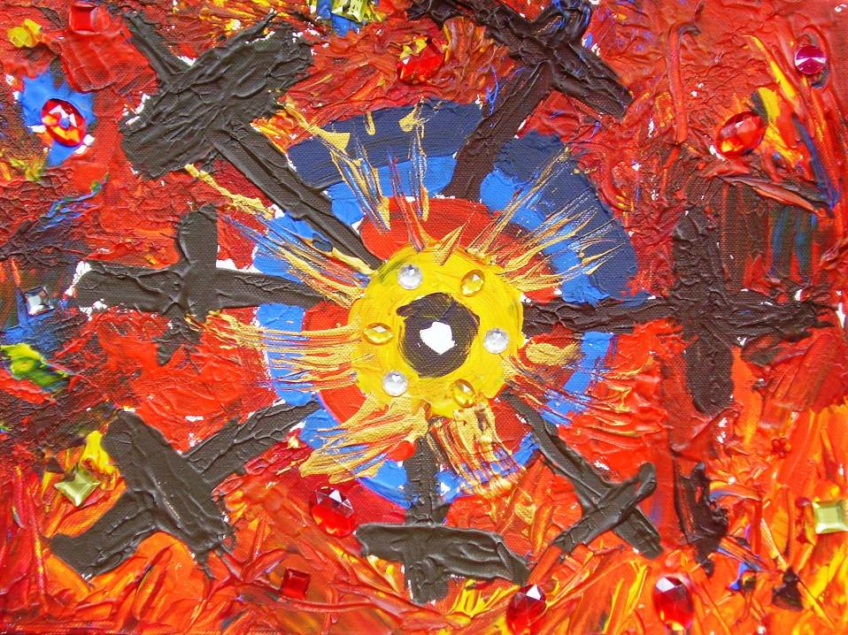
How do people
express their ideas
about God?
A Unit of RE for the Diocese of St Albans, Year 5/6

Year 5/6
© Diocese of St Albans & RE Today 2008
How do people express their ideas about God?
Year Group 5/6
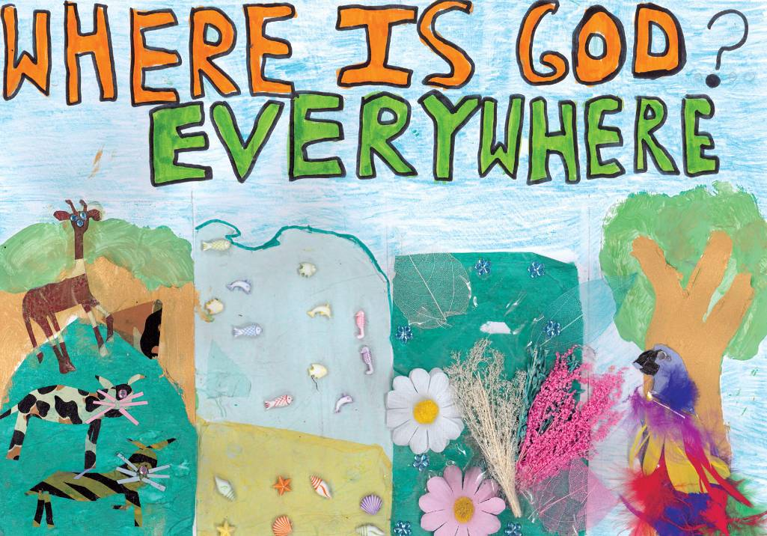

ABOUT THIS UNIT
This unit of RE focuses on some of the ways in which poetry, music, art, architecture and drama are used to express aspects of Christian understandings of God. There is a comparative activity which attends to the similarities and difference between Muslim or Hindu understandings of God as well. The main focus is on Christianity. The unit provides opportunities for children to experience how different art forms can be used to express feelings, emotions and intentions (linking with Social and Emotional Aspects for Learning, (SEAL)). Pupils will learn how these art forms are used in a religious context to express faith and insight into beliefs about God. The unit provides for pupils to make their own self-expression of their understanding of God in an artistic medium.
Estimated time for this unit: Usually 10+ hours of teaching time.
Where this unit fits in: This unit will help teachers in fulfilling local Agreed Syllabus requirements. It has been designed to connect with the Agreed Syllabuses for Bedfordshire, Luton, Hertfordshire and Barnet in appropriate ways, and reflects the learning model of the National Non-Statutory Framework for RE (QCA 2004).
RE IN THE CHURCH OF ENGLAND SCHOOL
- This unit makes an important contribution to the RE curriculum in the Church of England school, and connects with the intention that RE should be excellent by enabling the spiritual develop-ment of all pupils through a reflective and thoughtful study of Christianity and of religious and spiritual ideas. In this unit, the focus on God and talking about God is at the heart of the exploration of ultimate questions.
- Quality RE in the Church of England school makes space for pupils to explore questions and makes the resources of the Christian tradition available to them. Learning about Christian ideas, symbols and expressions connected with God is at the heart of this work.
- It takes the personal worth of every child, and the family culture of each seriously, seeking to explore religious ideas and emotions in ways that are authentic and have integrity. The idea that every child matters to God is explored with pupils.
- It offers opportunities to children to think for themselves, and be broad-minded and open-hearted in their encounters with faith, and to develop their own beliefs and ideas about God.
Issues of continuity and progression: This unit builds upon the Y3/4 unit on Jesus, and connects to the skills pupils are developing in literacy. It can be organised to make a key contribution to learning in the expressive arts curriculum.
KEY STRANDS ADDRESSED BY THIS UNIT
- knowledge and understanding of religious beliefs, teachings and sources
- knowledge and understanding of ways of expressing meaning
- skill of asking and responding to questions of identity, diversity and belonging
ATTITUDES FOCUS
- Self-awareness: this unit provides for pupils to develop their awareness of their own beliefs and their own creative abilities.
- Appreciation and wonder: this unit enables pupils to experience the power of the arts in responding to spiritual issues and questions for themselves.

Prior learning | Vocabulary | Resources

It is helpful if children have:  participated in drama and role play  visited different places of worship and begun to compare the practices and rituals of believers  learnt the techniques of mixing colours and of using different materials to create texture  collaborated with others in group work  participated in movement and dance activities using music | In this unit children will have an oppor-tunity to use words and phrases related to:  Religion:  - Christianity, eg vestments, stained glass, icons, festival, service, miracle plays, Pentecost  - Islam, eg prayer mat, mosque, mosaic, calligraphy  - Hindu, eg murtis, gods and goddesses, Shiva, Ganesha, Ultimate  Religious study and shared human experiences: eg  - the language of emotions of worship  - ideas about self-expression in arts  - the language of expressive arts (dance, drama, sculpture, glass art, painting, textiles, music) | Text  - Margaret Cooling - Jesus Through Art (RMEP), 1998  - Wood, Logan and Rose - Dimensions in Religion: Places and Spaces (Nelson Thornes)  - Phil Grice - Active Resources for Christianity 1 (Heinemann) - ISBN 435303724  - ‘I Wonder’ (Story of St Alban)  - A useful pack of materials for exploring Easter at different levels is published by the Diocese of Bath & Wells, 2002, Easter: a whole-school scheme of work, Wells: The Old Deanery RE Resources Centre. Price £10  - Picturing Jesus and Picturing Easter (RE Today, 2003/2008) provide good ideas for visual learning here.  Web  - The National Association of Teachers of RE ‘Art in Heaven’ gallery on the web show cases over 100 brilliant pupil responses to the questions ‘Where is God?’ and gives access to a free download of usable PPT sequences on this topic. It is a core resource for this module. www.natre.org.uk/spiritedarts  - Websites on Christianity, eg http://www.request.org.uk/  Artefacts  - Religious artefacts available to purchase from: Articles of Faith (Tel: 0161 763 6232)  - Religion in Evidence (Freephone 0800 137525)  - Icon – ‘Jesus through Art’, Margaret Cooling  - Vanpoulles is a supplier of vestments and textiles to churches. They have a very easy to use visual website: www.vanpoulles.co.uk.  - www.theresite.org.uk  - www.re-xs.ucsm.ac.uk/schools/  Audio, visual and video resources  - Contemporary classical spiritual music is good to use in this area: John Tavener, John Rutter, Andrew Lloyd Webber are examples.  - Some contemporary artists such as Bill Viola or Mark Wallinger offer challenging imagery as well (web links)  - Worlds of Faith: Channel 4, ‘Ganesh - The Elephant God’  - Local Radio Commentaries, BBC Five Live (CD or website)  - Cumbria and Lancashire Learning Online has  excellent resources for RE: www.cleo.net.uk Look in Subjects, RE, KS2.  - www.ngfl-cymru.org.uk is the Welsh Virtual Teacher Centre. It contains some good materials for teaching to this age group. Look at the KS3 sound presentation on Worship (very useful in this unit for Y5-6).  - examples of music from different religions  - posters, photographs and postcards of paintings  - miracle plays translated for children  - internet sites  - museums and art galleries  - www.fischy.com provides some of the best contemporary music for children in Christianity  Architecture and music:  Schools will do well to connect with local examples of Christian architecture and music in this unit.
KEY QUESTIONS | LEARNING OBJECTIVES  Pupils should learn: | TEACHING AND LEARNING  Practical classroom suggestions that will enable the teacher to see how to plan lessons. | LEARNING OUTCOMES  Pupils will be able to: | POINTS TO NOTE
What do we mean by self-expression? | To think about how we express ourselves, especially our deepest commitments and ideas  To recognise that expressing faith involves feelings and emotions  To describe how feelings can be expressed through movement in response to music | How do we express our feelings?  - Explore with the children facial expressions, body language and tone of voice, eg shouting, whispering.  - Develop a drama activity: ‘EMOTIONAL MOVEMENT’. Pupils in groups create a three-minute mime sequence using examples of emotions. They plan and perform moving through a range of emotions such as excitement, anxiety, fear, relief, puzzlement, sadness, despair, regret, exhilaration, amazement.  - This sequence is one interpretation of the events of Holy Week. Pupils can return to this later in the unit.  - Discuss other ways of expressing our feelings to others, such as writing poems, diaries, letters, stories, paintings, sculpture, music and dance.  - Watch a video of a piece of dance. Ask the children to note down what feelings are being shown. Discuss their notes as a class. Use movement or drama to show their understanding of how people express their feelings  - There will be children from traditions which do not use the arts as a means of religious expression, eg Quakers, so do not assume that the arts are meaningful for all religious groups. | Describe different emotions and feelings, making links to the ways characters in film or story might feel (L3)  Make links between characters in stories and themseles on the basis of shared emotions (L3)  Think about the stories that have emotional power for them.  (Literacy connection) | This unit is about the express-ive arts as well as about RE and PSHE. It’s good from the start to show pupils the inte-gration of these areas, and to plan learning which is dramatic, artistic and musical. The unit makes wide use of pupils’ multiple intelligences.

What do people believe about God? What do Christians believe? | That God is an idea which people find both important and mysterious  That there are many different ways of expressing beliefs about God  To think carefully about their own images, beliefs and ideas about God, and compare these with other, different ideas | Picturing and describing God  - Provide pupils with range of images of ‘God’. Ask pupils to consider which most closely reflects their own ideas – or add their own to the sheet (if appropriate – remembering Muslims do not depict God or Muhammad in pictorial form).  - Use a selection of views of God from young children. Either listen to CD track 2 (Heinemann Active resources pack) or use quotes from ‘Faith in the Future’ p15, or the database of pupils’ writing at www.natre.org.uk/childrentalking. Compare them with list of attributes of God - eternal, creator, transcendent, immanent, omnipotent, omniscient. (See Pupil resource sheet, p27, Heinemann.)  - Talk about/look at children’s images of God. There are dozens available at www.natre.org.uk/spiritedarts Talk about where children get their ideas from about God.  - Provide pupils with a ‘fact sheet’ which lists the key terms used to describe God. The definitions should be listed separately - pupils match words to definitions (as a test of their under-standing!).  - Set two questions for written response: ‘Explain two ways people describe God. Describe two things which influence people’s ideas about God’. Emphasise to pupils that the reason for the diversity of images may be about the mysteriousness of God. | Describe some different ways in which people try to say what they believe about God (L3)  Make links between different forms of expression, eg in words, in images (L3) | This work connects to the curri-culum for both ICT and art.

How are Christian beliefs about God expressed in various ways? | That beliefs about God can be expressed in words, but also in music or art  To develop skills of comparison and discussion in relation to the task  To understand some Christian beliefs about Jesus and the varied ways they are expressed | Comparing expressions of beliefs  - Begin by asking pupils to look at a copy of the Creed. Print it in the centre of a piece of A3 or A2 paper, and get pupils in fours to write 10+ questions about the words around the edge. This will help pupils to read carefully, and shows the teacher what they do – and don’t – understand already.  - Use a piece of music (a song such as or a hymn such as ‘There is a green hill far away’ is suitable), an image of a stained glass window (possibly showing the Last Supper, Crucifixion or Resurrection) and the words of the Creed that express ideas about Jesus. Ask pupils to talk about which is the best expression of Christians’ beliefs about Jesus and why.  - Begin by putting pupils in groups of six, with each of the three stimuli to consider. Three pairs must each argue for the item they have been looking at: what makes it good.  - Share ideas and arguments on the whiteboard, and have a class vote on which is the best expression of beliefs about Jesus | Describe three different expressions of beliefs about God and Jesus in Christianity (L3)  Make links between these three items (L3)  Show that they understand the variety of expressions of belief in music, stained glass and words (L4) | Making room for the pupils’ voice in RE is powerful because it shows the teacher ‘where they are at’ and gives the pupils the chance to direct their own learning.

How do the images, paintings and sculptures of Christians today express beliefs about Jesus and the worship of God? | That colour can be used to express religious feelings and ideas  That art can be sacred and spiritual for believers  Understand the variety of symbolic meanings in paintings | Can you express moods and feelings in colour, paint and art? Why is this important?  - Ask a member of the clergy to bring the coloured vestments for different seasons of the Christian year. What do the colours used in church symbolise? Help the children to carry out research to find out about the stories and symbols in some Christian festivals and design and make a banner for a festival, such as Pentecost.  - Explain the meaning of vestments and colour in many churches  - Identify and explain the significance of some symbols in Christianity.  In what different ways have artists expressed their beliefs about Jesus?  - Ask the children to suggest why people engage in artistic activity.  - Study reproductions of famous artists’ portrayals of the life, death and resurrection of Jesus, and his teachings. Explore how they use symbolism, colour and texture to express meaning. Compare a range of traditional and modern art. Explore by questioning. How does the work of art make you feel? How do you think the artist felt? How are images used to teach religious beliefs, to instil moral values or to inspire passions? How much do artists try to illustrate religious texts authentically or present personal interpretations? What is the artist taking from the Bible, and what is being added to the Bible?  - Children could paint their own images of moments from the Gospel narratives they choose themselves. Make links to the art curriculum to find appropriate time, resources and skills for this activity.  - Use the IWB to explore the pictures you choose – the searchlight tool is particularly good for this. | Describe some ways in which art can express emotions (L3)  Describe and show that they understand the ways in which Christian artists express their beliefs about Jesus through their work (L3/4)  Express some views, beliefs and ideas of their own in a piece of art work that is spiritual for them (L5) | There are cross-curri-cular links with art and design, using the correct colours, styles and textures for painting images of Jesus such as Orthodox icons.

How do Christian communities use and enjoy music to express their beliefs about God? | That many forms of music are used by the Christian communities to express worship, beliefs and faith  To understand how religious beliefs, ideas and feelings can be expressed in a variety of forms of music  To explain different forms of the symbol-ism and use of music in Christian worship  To identify and recognise different types of religious music and its symbolism | How and why do we find music moving?  - Listen to a joyful piece of music. Choose a piece of contemporary or classical music and ask children to reflect on it. How does music make you feel?  - Enable the pupils to choose how they want to respond to the music, eg through paint, through words, through movement. Help them to explore by questioning. What emotions did I feel in the activity on painting, creative writing or dance? What sort of feelings might people of faith experience in worship (eg love, peace, tranquillity, wonder, awe)?  How do Christians use music for worship and expression of beliefs?  - In small groups, ask children to prepare a response to the music, from the perspective of a group of Christian believers expressing feelings of joy to their God.  - Consider with pupils some songs they know from Collective Worship. Which would Jesus’ favourites be? Why? What do the songs express about Jesus and about God?  - Using a range of instruments, get groups of pupils to compose their own music to express a series of emotions: examples might include joy, thankfulness, sadness, fear, excitement. Enable pupils to present their work to the whole group (or to younger pupils). It may be possible to do a performance for an assembly.  - Include examples of religious words set to music which are familiar to the children, eg a setting of the Lord’s Prayer, of Psalm 23, the Hallelujah Chorus. Make sure you include examples of child-friendly contemporary Christian music, such as those from ‘Kid’s Praise’ or the Sticky Kids, or Steven Fischbacher’s extensive ‘Fischy Music’. | Make links between the music of the Christian community and the beliefs of the Christian community (L3)  Show they understand how and why Christians use music to worship God (L4)  Apply some of their own spiritual and religious ideas to the music they love (L4) | There are cross-curricular links with music and PE.  Music is an effective medium of com-muni-cation for children with learning diffi-culties.  PE, through team working, provides many oppor-tunities for spiritual and moral develop-ment.  This aspect of the unit can be extended for some children if appro-priate.

Six pieces of music for my spiritual iPod
- Ask pupils to think about their own ‘spiritual music’: what music would they choose to express their own deepest ideas? Ask them to choose six songs, or pieces of music that they would call ‘spiritual’ on their iPod (if they had one).
How can a building express beliefs? | To understand that the architecture of a Christian building is an expression of belief and worship  To apply the idea of expressing beliefs through buildings for themselves | How is faith expressed through the buildings Christians make?  - From virtual tours, photographs or a visit if possible, explore with pupils the significance of a major Christian building. (St Albans Cathedral is only one example, but a good local one: there is a virtual tour at www.stalbanscathedral.org.uk.)  - Ask pupils to consider first of all what did the people who made this building believe in? What mattered to them?  - Give pupils ten or more possible explanations of the meaning of a great religious building and ask them to rank these, first from the point of view of the people who worship there, then from their own point of view.  - Examples: St Albans Cathedral expresses these beliefs:  - God is there when people meet together  - Humans need holy places to help them think about God and life  - The history of Christianity helps makes sense of Christianity today  - Silence and music can help us listen to our own hearts. | Describe some ways in which a church building can express Christian beliefs (L3)  Show under-standing that the great religious sacred spaces are not like museums, but have a function today to inspire people to worship (L4) | There are good links here to the history curri-culum, in which pupils learn to ‘decode’ a building from the past and make sense of its archi-tecture.

How can drama express beliefs? | That drama is a means of reinforcing important stories and teachings in religions  How drama often reinforces teaching of the faith stories of the Bible (eg Parables)  That they can use drama to express their own under-standing of a religious or spiritual question | How have Christians used drama to express their understanding of Jesus’ teaching?  - Children view a video of Christian dramatic re-telling of a part of the gospel narrative, to open up the idea that drama can present old stories in fresh ways. For example, in Christianity, children might engage with mystery or miracle plays, versions of the parables (eg from BBC RE Curriculum Bites: The Tramp’s Parables).  - In teams, pupils dramatise one of the Parables of Jesus: the Lost Coin, the Lost Son (Luke 15), the Pearl (Matthew 13) or the Parable of the Talents (Luke 19). This can be done by improvisation, but some scripted versions are also available.  - If time is available, actors can design and make costumes/ masks and write descriptive accounts of their own feelings, and those of the characters they portray. The work could be presented in assembly to younger pupils in the school.  - Consider with pupils: How do these dramatic stories link up to questions about right and wrong, life and death, God and religion?  - Talk about how drama can be a means for presenting and reinforcing religious stories and teachings, and reflect on ways in which stories can be a means of exploring values, beliefs and big questions. | Describe the meaning of one of Jesus’ parables through taking part in a drama (L3)  Show under-standing of the links between drama and story from the Bible (L4)  Apply ideas from Jesus’ teaching in group drama work (L4) | This work can be con-nected to elements of the speaking and listening pro-grammes of the renewed literacy frame-work.

What have we learned in this unit of RE? | To reflect for themselves on their own ideas about spiritual life and self-expression  To respond to the challenge of self-expression of the spiritual in a way they choose | Expressing their learning: how can their own spiritual ideas be shared?  - Spend some circle time with the class reviewing the unit and its stimuli.  - Ask each child to choose: if they could select one piece of music, drama, poetry, art and archi-tecture to sum up Christian beliefs about God, which ones would they choose and why?  - Ask pupils to make a small booklet of ten pages. Five pages should have a picture of the five things they selected above. The facing page in each case should answer the question: why does this express spirituality to me? (or similar)  - This booklet is a suitable item for an assessment if you need one for this unit.  Challenge: Can you make a piece of creative work to express your own spirituality?  - In association with the Art curriculum, enable pupils to plan, design and make a painting, poem, dance, drama or sculpture that expresses their own sense of the spirit.  - Pupils might express their sense of the spiritual with reference to self, others, the earth or God (‘the transcendent’ if you prefer)  - This work will be enhanced by good modelling. www.natre.org.uk/spiritedarts showcases some brilliant children’s work in the web gallery for the ‘Art in Heaven’ competition.  - A gallery or exhibition of the pupils’ work would be a great starting point for younger children to see in their work on ‘talking about God’ (Y1). | Describe some things that express the spirit of Christianity. (L3)  Show, using the right words, under-standing of how different art works express Christian belief (L4)  Express their own views about the ways Christians’ spirituality is expressed in the arts and architecture (L5) | Use a broad definition of ‘spiritual’ for this work – model inclusivity so that anyone can be ‘spiritual’ whether they are conven-tionally ’religious’ or not.  This task meets object-ives at L4 in the art curri-culum: making purpose-ful images and arte-facts, drawing to express/ visualise /dream/ imagine.

© Lat Blaylock for the Diocese of St Albans, February 2008

SUMMER TERM

How and why are wind and fire symbols of Pentecost?

WALT and Success Criteria | Main Activities | Resources | Assessment
WALT: understand what Pentecost is.  I can listen to different stories of how the Holy Spirit is represented and compare them. | - Explain to the children that in Palestine the wind comes from East or West and brings two very different experiences. The East wind is a destructive and powerful force that destroys life. The West wind is a refreshing, gentler wind that brings gentle rain to the land.  - Both these descriptions were used by Old Testament writers to understand how God can act in different ways e.g. as awesome judge or gentle sustainer and refresher. Read the story of Elijah (1 Kings 19) and his experience of God as a still, small voice. How do you think Elijah saw God, how did he experience God?  - Explain how at the celebration of Pentecost (celebrated 50 days after Easter Sunday) Christians celebrate the Holy Spirit.  - Compare the story of Elijah with the story of the Pentecost which happened when Jesus’ apostles were celebrating the Jewish festival of Shavuot. The Holy Spirit came upon them. It looked like a strong wind and tongues of fire and made them speak in foreign languages. People passing by thought they were drunk but Peter explained it was the Holy Spirit.  - Why were the apostles celebrating a Jewish festival? Did they see the Holy Spirit in the same way as Elijah? What might a Christian learn about the Holy Spirit from this story?  - Suggested task: ask the children to act out the two different stories, each group taking on one of the stories and compare the two experiences of the Holy Spirit. | Story of Elijah – 1Kings 19.  Story of Pentecost | Sub question: What is Pentecost?  AT1 (L3) – ‘I can describe what a believer (religious person) might learn from a religious story.’
WALT: explore the symbols of Pentecost and the Holy Spirit.  I can explore different symbols of the Holy Spirit and explain what I think they represent and why. | - Recap work from last week.  - What are the symbols of the Holy Spirit? – fire and wind.  - Why do you think these are symbols of the Holy Spirit?  - Discuss how the Holy Spirit often appears to people in the Bible as wind or fire.  - Discuss the significance of both of these and how they can be both nourishing and dangerous just like the God of the Old Testament.  - Do you think the Holy Spirit is seen in different ways by different Christians.  - Suggested task: look at different symbols of the Holy Spirit – what do you think they represent and why? What do you think the Holy Spirit is like judging from this symbol? Feedback to the rest of the class. | Symbols of the Holy Spirit at Pentecost. | Sub question: How is the Holy Spirit symbolised at Pentecost?  AT1 (L3) – ‘I can use religious words to describe some of the different ways in which people show their beliefs.’
WALT: explore how Pentecost is celebrated.  I can watch a video clip of Christians celebrating Pentecost and discuss what I can see and why.  I can work in a group to create my own Pentecost celebration explaining what I have created and why. | - Recap work from last week.  - What do you think Christians do on this day?  - Discuss how it is a happy festival as it celebrates the Holy Spirit and it is also known as Whitsun.  - Show a video clip of Christians celebrating Pentecost within Church.  - What did you see? What was happening and why?  - Tell the children that Pentecost is the birthday of the Christian Church and the start of the Church’s mission and so it is a very important celebration.  - Why was the vicar wearing red robes? Talk about how they represent the Holy Spirit.  - Suggested task: in groups create your own celebration for Pentecost – what would you do and why? Think about what Christians already do to celebrate and how you would show this. | Video clip of Christians celebrating Pentecost | Sub question: How do Christians celebrate Pentecost?  AT1 (L3) – ‘I can use religious words to describe some of the different ways in which people show their beliefs.’  AT2 (L3) – ‘I can compare some of the things that influence me with those that influence other people.’
WALT: explore the importance of hymns in the Pentecost celebration.  I can listen to a hymn sung at Pentecost and explain what I think it might tell Christians about the Holy Spirit.  I can write a hymn to be sung at Pentecost, thinking about why Pentecost is celebrated. | - What kinds of hymns might be sung at the Pentecost celebration?  - Look at the words of the hymn ‘Spirit of God Unseen as the Wind.’  - Could get children to have a go at singing it.  - What is this hymn saying? Why might this be sung at Pentecost?  - Talk about how it tells Christians about the different experiences of the Holy Spirit and the different ways in which it is represented.  - Suggested task: in pairs or groups ask children to write words to a hymn to be sung at Pentecost, thinking about why Christians celebrate Pentecost and the fact that it is a happy time! | Hymn – Spirit of God Unseen as the Wind. | Sub question: How do Christians celebrate Pentecost?  AT1 (L3) – ‘I can use religious words to describe some of the different ways in which people show their beliefs.’
WALT: explore if the Holy Spirit is still important today.  I can listen to accounts of the importance of the Holy Spirits in people’s lives today and compare them.  I can create a dance to represent the Holy Spirit thinking about the different ways in which Christians experience it. | - Do you think Christians still experience the Holy Spirit today?  - Find accounts of different Christian experiences of the Holy Spirit and discuss and compare.  - Is the Holy Spirit still important to Christians today?  - Suggested task: in groups create a dance about the Christian experience of the Holy Spirit – think about how Christians see the Holy Spirit as two opposing ideas, a rushing wind and a still gentle wind. | Christians experiences of the Holy Spirits. | Sub question: Is the Holy Spirit still important today?  AT1 (L4) – ‘I can show how beliefs are connected to believer’s lives.’  AT1 (L4) – ‘I can express religious beliefs in a range of styles and words used by believers and suggest what they mean.’  AT2 (L4) – ‘I can ask questions about the moral decisions that I and others make and suggest what might happen as a result of different decisions, with reference to religious beliefs and values.’
WALT: explore artwork of the Holy Spirit.  I can look at some artwork of the Holy Spirit and discuss what I think the artist was trying to tell me about it.  I can create a piece of art of the Holy Spirit and explain why I created them. | - Why is the Holy Spirit so important to Christians? Remind children that the Holy Spirit is part of God and so it is important as it makes up a third of the Trinity.  - Look at some artwork of the Holy Spirit – could be created by other children as well as adult artists.  - What are the artists of these pictures trying to tell us about the Holy Spirit? How has the artist been influenced by the Holy Spirit.  - Suggested task: children to create artwork of the Holy Spirit, writing an explanation of why they created it. | Artwork of the Holy Spirit | Sub question: How is the holy Spirit represented in art?  AT1 (L3) – ‘I can describe some of the things that are the same and different for believers.’  AT2 (L3) – ‘I can compare some of the things that influence me with those that influence other people.’

Belonging – How and why should we get on with others?

This unit focuses how world and religious communities and how they work together to get on and make the world a fairer place. Pupils will have the opportunity to discuss the groups that they belong to and compare the Christian with the Buddhist community.

Learning objectives and success criteria | Main activities | Resources | Assessment
WALT: explore the different groups we belong to.  I can discuss and note down the different groups that I below to and how they are connected. | - What kind of groups do you belong to?  - What kinds of religious groups can you think of?  - Play all the same all different – have cartoon pictures of religious children with their religious symbols on them and groups that they belong to. Ask pupils which of the pictured children they think belong to each group and why. They will soon realise that they could all belong to each group – rejects stereotypes!  - Why do you belong to these groups? How do they affect your lives?  - Discuss how you could call these groups communities such as our school.  - Discuss a religious community shared activity such as harvest – think about how this connects our school community to others.  - Children to make their own web of belonging, putting on it all of the groups that they belong to and how they are linked. | All the same all different on IWB (in RE resources) | Sub question: Where do I belong?  AT1, L3 – ‘I can describe some of the things that are the same and different for religious people.’  AT2, L4 – ‘I can ask questions about who we are and where we belong, and suggest answers.’
WALT: discuss what the world community is like.  I can discuss whether or not I think the world is fair and why.  I can think of 5 benefits and 5 difficulties that might arise from living in an unfair world and discuss these with my partner. | - Recap theme of communities.  - What kind of world communities do we have? Talk about how the world is a community in itself.  - In a community what do we do for each other? Talk about sharing; looking after each other etc.  - Use ‘If the World Were a Village’ – get 100 jelly babies to demonstrate how if they world were a village with just 100 people in it:  - 60 would be Asian; 8 Latin American; 14 African; 5 from USA and Canada; 12 European; 1 from Oceania.  - 33 would be Christian; 6 Buddhist; 22 Muslim; 15 Hindu; 10 other; 14 none.  - 50 would not have enough to eat; 17 would not have clean water.  - 1 would go to university  - The same 7 people would have a car and a computer.  - What do you think of this information? Use pictures from ‘RE Today booklet – Opening up Respect pages 21-22’ to stimulate discussion.  - In pairs ask the children to write down 5 benefits and 5 difficulties that might arise from living in this village.  - Plenary: discuss the different ideas everyone came up with. Do the difficulties outweigh the benefits? Is this village fair? Remind children that this is based on the actual world! | Pictures from RE Today booklet – ‘Opening up Respect’ (pages 21-22)  If the World Were a Village book. | Sub question: What is the world community like?  AT1, L3 – ‘I can use religious words to describe some of the different ways religious people show their beliefs.’  AT2, L4 – ‘I can ask questions about the moral decisions I and other people make, and suggest what might happen as a result of different decisions.’
WALT: understand why we need rules to live in a community.  I can think about how rules might help me to live peacefully with others.  I can write my own rules for living in the village of 100 people, thinking about how I will make it a fair place. | - Recap last lessons work and remind children of the world as a village and recap using the pictures.  - Teacher to put up some of the statements that different religions have said to help people live in harmony. (See RE Today Booklet – Opening up Respect – page 24) What do you think these mean? Discuss how these might help a religious person to live in harmony with others and how all communities have to have rules to help them live in harmony.  - What rules might you be able to make for living fairly in the village of 100 using these statements? e.g. share with each other.  - Children to design a t-shirt, poster, advert, power point etc advertising rules for living in a harmonious community in which everything is shared out fairly. | RE Today Booklet – Opening up Respect page 24; statements that religions have said to help people live in harmony on IWB. | Sub question: Why does society need rules?  AT1, L4 – ‘I can express religious beliefs in a range of styles and words used by religious believers and suggest what they mean.’  AT2, L3 – ‘I can ask important questions about life and compare my ideas with those of other people.’
WALT: understand how and why symbols represent different communities.  I can think about the different symbols used to identify different communities.  I can think of different symbols to represent myself including the groups that I belong to and say why I chose these. | - Teacher to put up a variety of symbols from different religious and non-religious groups.  - Can anyone identify any of these?  - How did you know what community they belonged to?  - Discuss how symbols are used to show something about a group or community and identify them.  - Discuss meaning behind some of the symbols.  - Think about how the way that people dress and have their hair can often tell you something about what they are like. Teacher to put up pictures of religious and non-religious people and ask the children to discuss what they think their dress says about them.  - Children to draw themselves with different clothes on, designing them to show what different groups they are part of and then write sentences to say what each item of clothing represents. | Symbols from different communities on IWB | Sub question: How do people show what groups they belong to?  AT1, L3 – ‘I can use religious words to describe some of the different ways in which people show their beliefs.’  AT2, L4 – ‘I can suggest a range of answers which might be given by me as well as members of different religious groups or individuals.’
WALT: understand how people might show that they belong to a community.  I can talk about how Buddhists and Christians celebrate belonging to their communities.  I can design a day to celebrate belonging to our school community. | - Recap last week’s lesson.  - What kinds of things do people do to show that they belong to a community or religion?  - Talk about Christians and how when they first come into the community they are baptised.  - Discuss baptism - http://www.request.org.  uk/main/dowhat/baptism/baptism00.htm  - How do you think people feel in an initiation ceremony? Remind children of different ones and the fact that not all Christians get baptised as babies.  - Has anyone been through an initiation ceremony for anything? How did it make you feel?  - Talk about how Buddhists don’t have an initiation ceremony, but instead they just belong to the Sangha and celebrate this on Sangha Day – helps them to feel part of something. Talk about how on this day they exchange gifts, chant, meditate and light oil lamps.  - Suggested task: Ask children to design a day to celebrate them belonging to the school community. What kinds of things would they do and why? | Baptism ideas on internet. | Sub question: How do people show what groups they belong to?  AT1, L4 – ‘I can use the right religious words to describe and compare what practices and experiences may be involved in belonging to a religious group.’  AT2, L5 – ‘I can give my own and other’s views on questions about who we are and where we belong.’
WALT: understand how rules might help people to get on.  I can discuss the rules that religious people might live by and how easy it would be to always live by these.  I can discuss which rules I think are the most and least important and give reasons why. | - What kinds of things do we have in school to help us to get on with each other?  - Talk about school rules and display school or class rules. How do these help us get on?  - What would happen if we did not have rules?  - What rules do Christians have? Talk about the 10 Commandments – how do they help Christians to get along? Can you see any similarities between these and the rules of society?  - Teacher to display the Eight-fold path from Buddhism. Discuss what this means for Buddhists and how they should live their life by this.  - Do you think it is enough for religious people to say that they will live by these rules but not put them into practice?  - Would it be easy to always follow all of these rules?  - What rules would you put into your own set of rules for living a good life?  - In pairs complete the Diamond 9 (in Staff Resources – RE). Pick 9 of the rules given and put them into a diamond shape with the most important at the top and the least important at the bottom, giving reasons for each one.  - Join up with another pair and tell them the reasons why you put each card where you did. If time discuss as a class. | 10 Commandments  8 fold path  Diamond 9 cards from Staff resources RE – one set between 2. | Sub question: Do religions need rules?  AT1, L4 – ‘I can use the right religious words to describe and compare what practices and experiences may be involved in belonging to a religious group.’  AT2, L4 – ‘I can ask questions about who we are and where we belong and suggest answers which refer to people who have inspired and influenced myself and others.’

