

Important reminders

* Please make sure all items of uniform are clearly named
* Please make sure any money sent into school is in a labeled envelope
* Please make sure your child has their PE kit in school every day
* Reading – children in Year 6 are still expected to read at home every day.
* Homework will be sent home on Fridays. This will consist of one piece of literacy, one piece of maths and spellings. Please complete the homework and return it to school by the following Thursday.

Spring Term

2017

Year 6 Class Newsletter

Welcome to Holy Trinity

Welcome back! May we first take this opportunity to thank you for all the Christmas cards, gifts and good wishes. They were all much appreciated!

The Spring Term brings with it increased anticipation of the SATs. With that in mind, the Year 6 Team would like to invite parents/carers and pupils to a meeting on 18th January (further detail will follow) where parents and pupils can voice any concerns. Staff will be offering advice as to how children can be supported in what can be a stressful time for them.



What does learning look like in Year 6?

This year sees a new curriculum for Year 6 pupils, especially in English, Maths and Science. Some concepts will be new to the children, others will be more challenging.

**Reading**

Reading is still a vital aspect of your child’s learning. In Year 6, pupils need to progress from simply decoding words to responding appropriately to a text. Children need to read a range of texts, both fiction and non-fiction of a high quality.

**How can I support my child?**

Many of our children lack a sufficiently large vocabulary to keep them in line with other children of their age.

Please ensure that, when listening to your child read, you check that they understand what they are reading by asking questions about any unfamiliar language. What do the words mean? How can they work out what the words might mean from the context of their reading? Check that they realise that some words can mean the same type of thing (ie: synonyms – eg tiny, small, little).

The ability to understand what you are reading impacts on all areas of the curriculum. For example, even asking your child to describe what a term means in their maths homework will be beneficial.

Please ensure that Reading Records are signed on a daily basis.

**Writing:**

There will be an emphasis on writing – including spelling, punctuation and grammar (SPaG). Please encourage your child to use a range of vocabulary both in written activities, such as letters to family and friends, homework etc and whenever you ask them questions. Some of the writing foci will be linked to learning in Science or topic.

Our motto is:

**Alta Pete – Aim High**

“The primary aim of the school is to help each pupil reach his or her full potential so that they may develop the attitudes, skills and knowledge to take full advantage of the opportunities available in their future lives."

**Writing units covered this term:**

**Developing narrative writing**: We will be looking at the elements of stories and improving our skills in developing characters, settings and plot. It is important that children read widely and recognise good examples of characterisation, description and plot development in good quality fiction.

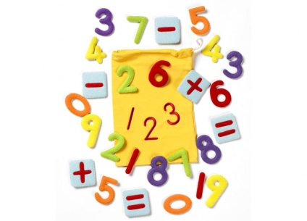

**Maths:**

Maths will include a higher emphasis on being able to explain mathematical processes as well as problem solve. We will begin by focusing on developing key number and calculation skills. This will include both mental and written methods. A key aspect of this will be ensuring that all pupils can rapidly recall their multiplication facts (up to 12 x 12) and extending this to decimals, eg 0.0089 x 100; 0.6 x 0.07; 7 x 7 x 7= .

Place Value – 10,000,000 to 1/1000 including decimals

Application of the four operations – Addition, subtraction, multiplication and division (including problem solving and reasoning)

Algebra will continue

Measures – including the dimensions and associated measurements of circles

Ratio and proportion

**How can I support my child?**

Encourage your child to learn/revise table facts – times tables tie into many aspects of maths!

Ensure that all maths homework is “given a go”! All maths homework underpins learning in class therefore if they are struggling with homework, this must be flagged up to Ms Phillips.

Maths booster classes start on 13th January – please support your child in arriving at school by 7.45am each Friday. Children are divided into small groups to enable the best provision for each individual.

The second half of this term will see the children studying stories which include a dilemma. There will an increased emphasis on Spelling, Punctuation and Grammar as we move towards Teacher Assessment for SATs.

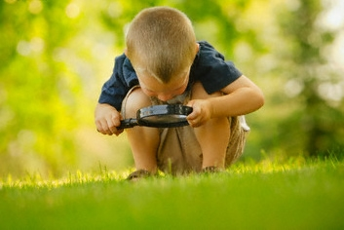

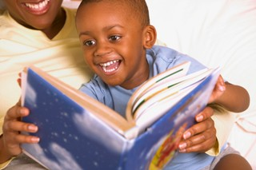

Science: We will be finishing our unit on electricity. We will then move on to investigate light ; extending our understanding of light sources and the formation of shadows and exploring how light is reflected.

Other Areas

Some lessons are harder to integrate into the topic so these will be taught separately when this is the case. These include:

R.E: We continue to follow the Discovery RE scheme. The key question for this term is: **Is anything ever eternal?** We will be exploring questions such as, “Should religious people be sad when someone dies? “, “How well do funeral and mourning rituals tell you about what a religion believes?” and “What happens after death?”

P.E. and Games:

This will be taught by Mr Waite and will include multi skills and invasion games. P.E. lessons are on Thursday and Friday. Please ensure children have kits in school including sweatshirts and joggers as many of the lessons will be outside.

PSHE:

PSHE will be closely linked to British Values.

Computing:

Computing – including E-Safety – will be taught according to National Curriculum requirements.

Topic: Our topic this term is Mountains. Children will extend their knowledge of the structure of the Earth and discover how mountains are formed. They will learn the names and locations of major mountains and mountain ranges and work to understand how the mountain environment affects human activity. We will also examine how plants and animals adapt to life in mountainous areas.

# 

# The Y6 team – Ms Phillips, Mrs Murdoch, Mrs Stoddard and Mrs Dave