The can you be seen Quiz
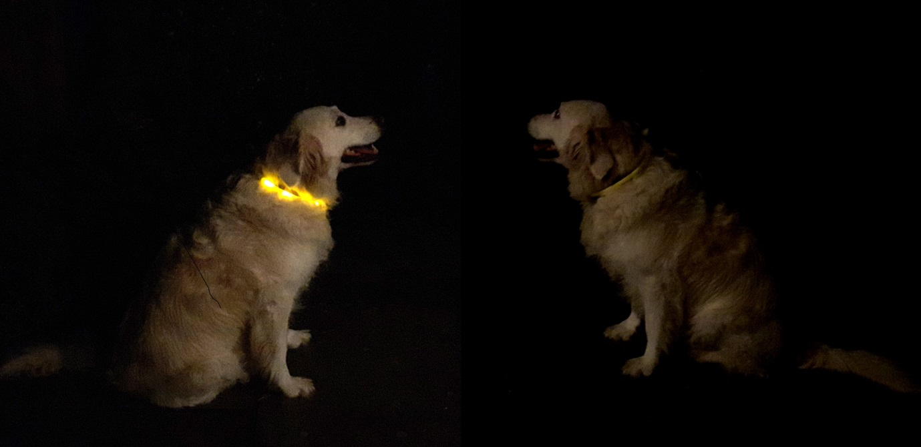
- What helps you to be seen in daylight?
- What material helps you to be seen at night?
- How much sooner can a driver see you at night if you are wearing or carrying?
- When do fluorescent colours show up best?
- What do you need for reflective material to show up?
- Why is ‘high vis’ clothing fluorescent and reflective?
- Which colour is the most difficult for the human eye to see? Yellow/Pink/Green/Blue
- Which colour is most popular with horse riders in the countryside?

Answers

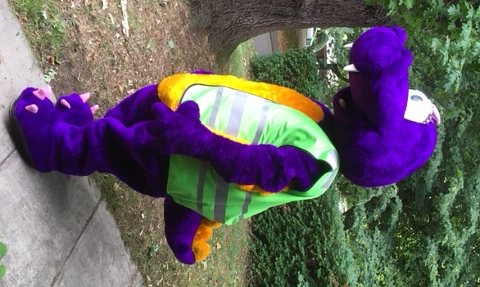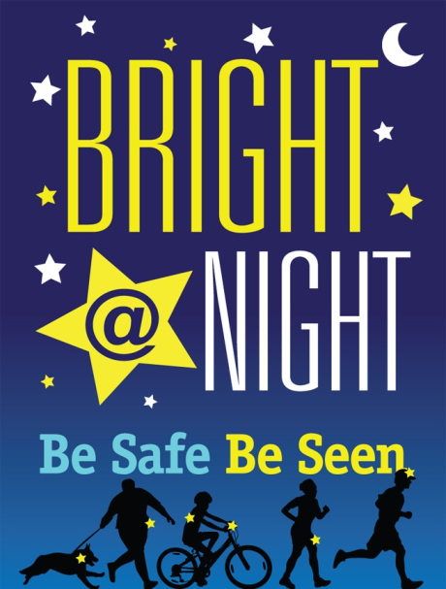

- Fluorescent
- Reflective
- Three seconds which could make all the difference
- In poor daylight such as mist or light rain but not when it is dark
- Light such as car headlights
- So you can be seen at any time of day and night
- Blue
- Pink as it contrasts with colours in nature, yellow is also popular.

