HOLY TRINITY CE SCHOOL

FEEDBACK POLICY - 2019

Policy Review

This policy will be reviewed in full by the Governing Body annually.

The policy was last reviewed and agreed by the Governing Body in 2019

It is due for review – 2021

Signature …………………………………. Date ……………………

Head Teacher

Signature ………………….………………. Date ….…………………

Chair of Governors

Introduction.

Ethos and Aims of Holy Trinity CE School.
Our status as a Church of England school is fundamental to our ethos and purpose. We expect all our staff to support our Christian ethos and aims.

At Holy Trinity School we believe in the concept of lifelong learning and the idea that both adults and children learn new things every day. We maintain that learning should be a rewarding and enjoyable experience for everyone; it should be fun.

Our mission statement is:
Alta Pete – Aim High
‘Let your light shine’

The primary aim of the school is to help each pupil reach his or her full potential so that they may develop the attitudes, skills and knowledge to take full advantage of the opportunities available in their future lives.
We achieve this by:
- fostering the values, attributes and lifestyles that a Christian faith demands in the family, among friends, in the school and in the wider community.

- creating an environment for staff and pupils that is happy stimulating and supportive in which core values and beliefs of high expectations can flourish

- providing an appropriate balanced education designed to help each pupil reach their potential.

- ensuring that all staff have access to development opportunities in keeping with the needs of the school and individuals’ expertise to enhance the educational opportunities for our children.

- providing effective management and organisation within the school to give clear guidance for its direction

- nurture the partnership role between School, Governors, Parents, Christ Church and the wider community for the benefit of the children for whom we are jointly responsible.

At Holy Trinity our Feedback Policy relates specifically to the ethos and aims to the school and the aims and objectives we seek to achieve in all curriculum areas. The purpose of the policy is to set out the principles and procedures of how we provide marking and feedback to our pupils and ensure they make good progress in their learning. This policy and the principles for providing feedback is based on the best practice from educational research, pulling together information from the Education Endowment Foundation and the work of educationalists such as Shirley Clarke and John Hattie.

All members of staff are expected to be familiar with the policy to ensure there is a consistent approach across the school. It is also important that pupils have a clear understanding of the way in which their work is marked and feedback given. The involvement of children in the process is at the heart of our ethos. We believe that pupils are partners in their learning and should understand the importance of improving their work and next steps to become reflective and independent learners.

We believe it is important to provide positive, constructive feedback which supports the development of children’s learning in achieving the challenging outcomes and reaching their learning potential. Feedback, both verbal and written, gives pupils a clear understanding of how to develop their work. The teachers check that pupils demonstrate their understanding by acting on the advice given.

Aims of the policy.

- To motivate children to want to produce high quality outcomes and make progress.
- To provide opportunities to show we value children’s learning outcomes. Teaching staff aim to encourage children to feel safe enough to learn from their mistakes and take risks.
- To develop children’s understanding of what they do well and how they can improve further.
- To help children challenge their work to achieve attainable learning goals set by teachers.
- To provide the means by which teachers are able to assess and evaluate whether the teaching and learning has been effective and to provide direction for the next steps of learning.
- To encourage pupils to be reflective about their learning and become independent in taking the next steps in their progress.
- To offer opportunities for peer and self-assessment, developing their understanding of the processes of learning and sharing those with others.

Marking and feedback will be:
- Clearly related to the learning objectives, success criteria and individual targets/next steps of the lesson.
- Meaningful and accessible to the individual child.
- Used to inform future planning and learning opportunities.
- Positive, constructive and improve children’s learning.
- Encouraging of a dialogue between the child and teacher/everyone involved in the process.
- Given verbally and in written form.
- Written in a neat and in a legible style.

Key Principles

We have looked at the latest educational research both from external sources and also worked with pupils to look at what they find useful in developing their learning.
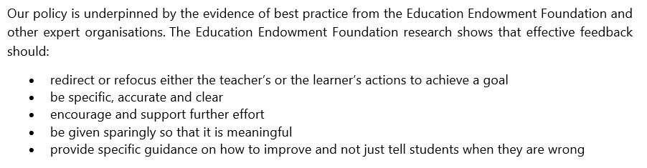

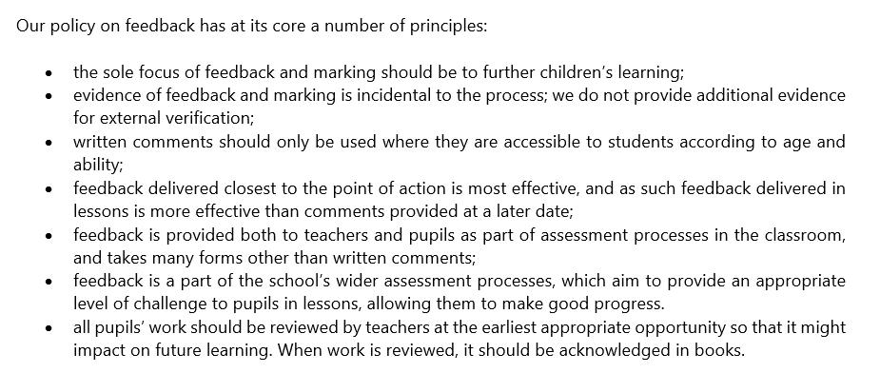
Feedback in Practice

Building on the work of the Assessment Commission, we have set out how feedback is given in three ways (in order of decreasing importance):
- Immediate feedback – at the point of teaching.
- Summary feedback – at the end of a lesson/task
- Review feedback – away from the point of teaching
We focus on making feedback to our children useful and valuable. We maintain that the most valuable feedback that comes from marking a book occurs in the first few seconds of looking at it. The benefits of quick feedback from teachers is more beneficial to pupil learning than written feedback.

The school policy aims to provide pupils with high quality feedback to take their learning forward and ensure that teachers use the most effective method of feedback instead of focus on written feedback which is less effective and useful to pupils and is incredibly time-consuming.

Evidence.

It is important to realise that the evidence of feedback can be seen in different ways other than written marking in children’s books. At Holy Trinity we have a highly effective monitoring schedule to ensure pupils receive high quality provision from our school. This cycle of continuing school development encompasses evidence collection as set out below.

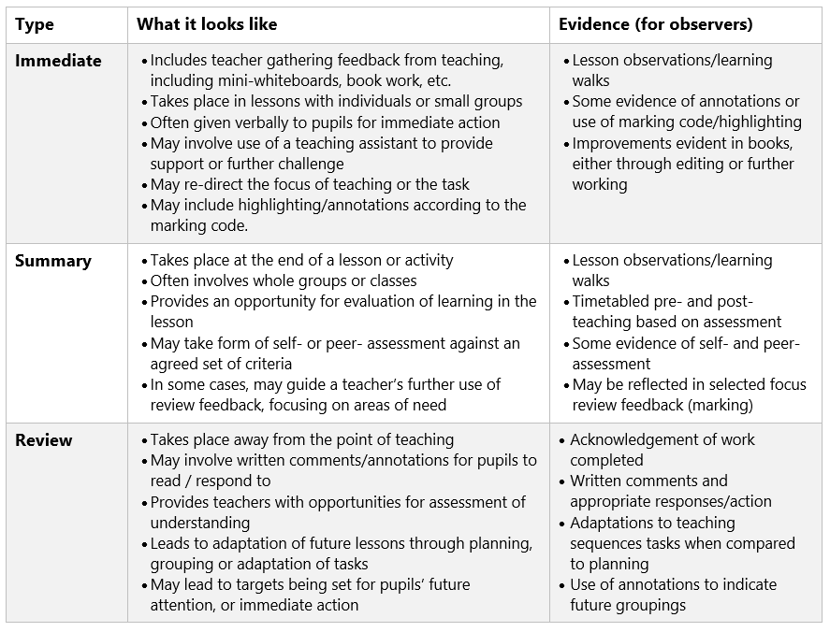

FEEDBACK GUIDANCE

Approaches to feedback.
Feedback will be undertaken in a timely manner during the lesson as much as possible or following the lesson if this is to review the progress towards the learning objective. It should take place within the learning environment with the child or group so that the dialogue can address areas for improvement in a timely manner.

Abbreviations and symbols are in place and are shared with pupils and families to ensure everyone knows what these mean and how they are used (see Appendix 1).
Teacher’s point of learning feedback will be in red pen, supply teachers/TAs in green pen.
Peer and self-assessment will be written in pencil or using the purple pens as appropriate.

Verbal Feedback.
It is important that all pupils receive regular verbal feedback from the adults. Verbal feedback will be noted by writing VF.

Self-assessment and peer feedback.
This is key to pupils taking ownership of their development and gain an understanding of ways in which they can progress most effectively. Pupils will be taught how to self and peer assess from the early stages of their learning, developing their understanding of ‘what a good one looks like’ (WAGOLL). It supports pupils’ ability to self-evaluate and reflect, become independent and self-motivated. It enables pupils to make amendments in pencil/purple pen to their own pieces of work, and use other pupils’ work – randomly – for peer assessment and then return to the originator for editing and improvement.

Feedback away from the point of learning
Teachers will:
- Indicate examples where the child has met or not met the learning objective/success criteria using pink and green highlighting.

Agreed Feedback Codes.

Blue and red marks at the WALT/learning intention (cold and hot marking) for showing improvement in writing.

EYFS and KS1

 | You have achieved the learning objective
 | Dot indicates WALT not met
VF | Discussed with pupil
 | ‘Green to be seen’ – Strengths/Celebrations
 | ‘Pink to think’ –Something to check/Re-try
 | You’ve made a spelling mistake

KS2

 | You have achieved the learning objective
 | Dot indicates WALT not met
VF | Discussed with pupil  Suggested action taken

Strengths/Success/Celebrations
Something to check/Re-try

