Important reminders!

- Please make sure your child is wearing the correct uniform and all belongings are clearly named.
- Reading books need to be in school every day and please remember to sign your child’s Reading Record.
- Please make sure any money sent into school is in a labeled envelope.
- Please make sure your child has their PE kit in school every day.
- Homework will be topic based and set half termly.
- Spellings will be sent home on Fridays to be tested the following Thursday.

Autumn Term
2019

Year 1 Class Newsletter

Welcome to Year One!
Hello and welcome to year 1. We hope you had a fantastic summer. The aim of this newsletter is to give you some insight into what we will be focusing on in the classroom for the rest of the term. I am so lucky to have had the opportunity to spend some time with your children while they were in Reception and get a head start on getting to know them. I am positive that we will have a great year together and I am very much looking forward to working with you and your child.
If, at any time, you have any questions or you are unsure of anything please ask. If I am unable to see you at the beginning or end of the day, please make an appointment to see me at a convenient time.

What does learning look like in Year 1?
The learning environment in Year One builds upon the children’s achievements in the Foundation Stage and introduces them to the National Curriculum. English, maths, phonics and handwriting will be taught daily and the remaining curriculum subjects are taught using a topic approach. We aim to plan interesting topics, which will inspire and motivate the children in their learning. We have included a ‘Farmer’s Market’ role play area in the classroom which will be used by the children to work on their number and communication skills. We aim to build lessons around the children’s current interests.

Maths
We will be working hard to develop children’s confidence in maths. Throughout the term, our main aim is to strengthen children’s awareness of place value and secure basic counting skills. We will also be focusing on:
- Describing position, direction and movement
- Representing and beginning to use number bonds to 20
- Addition, subtraction, doubling and halving
- Estimating ordering and regrouping
- Recognising, creating and describing patterns in numbers
- Names and properties of 2-D and 3-D shapes

During the children’s transition from Reception to KS1, Maths will be taught daily through an adult led activity. They will also have the chance to explore Maths resources independently during continuous provision time; this is when children can explore recent learning, practice new skills and follow their own interests.

Our motto is:
Alta Pete – Aim High
‘Let your light shine’
“The primary aim of the school is to help each pupil reach his or her full potential so that they may develop the attitudes, skills and knowledge to take full advantage of the opportunities available in their future lives."

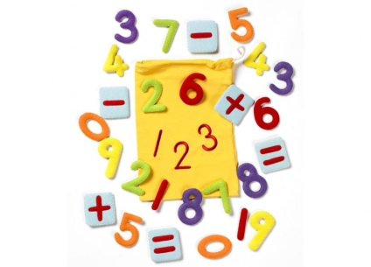

English
During the first half term we are focusing on labels, lists and captions.
The children will be writing labels and simple sentences which will link in with our other topics, for example, labelling parts of the body. We will also be exploring the following authors – Martin Waddell, Anthony Browne, Jez Alborough and Shirley Hughes.

We will be teaching phonics for 20 minutes daily. The children will be learning new sounds and practising their blending and segmenting skills which will support their reading and writing.

Reading is an integral part of our school day. As well as a daily designated class reading time, the children will access a wide range of texts throughout the day. They will be given opportunities to read texts during shared teaching, as part of a small group and individually. Your child will read with an adult in school at least once a week. It is important that your child brings their reading book into school every day so that we can maximise additional opportunities for them to read. Please encourage your child to read every day at home and make it a special time together. Remember little and often is the best way to develop a love for reading! Please can you sign the reading record when you have read with your child. As part of a new incentive to get children reading at home, when your child reads every day for the whole week they are in for the chance of being the Super Reader (and will be allowed to wear an extremely exciting super reader cape all day!). Also, each time your child reads they will earn themselves a sticker to put on their own reading chart; once that chart is filled up they receive a special reward.

Parents will be given the opportunity to take part in Story-time from 2.30pm on Fridays starting from Friday, 27th September.

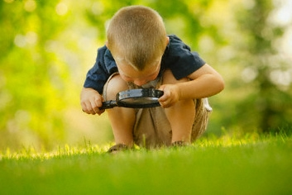

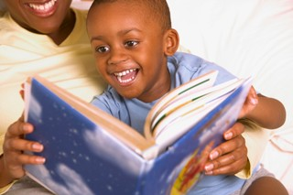

Science
Throughout the first half term, our science topic is ‘Our bodies’. The children will be exploring the five senses and learning about how to keep our bodies fit and healthy, including healthy eating, exercise, brushing our teeth and ensuring we are getting enough sleep.

Topic
We will develop the children’s ability to think about past events and use technical historical vocabulary. We will be finding out about our family tree and history. In RE we will be learning about the Creation and how we should respect our natural environment. In art and design, we are creating portraits of ourselves and our friends and family using a range of different materials and techniques. In our computing lessons, we are learning to use the computer independently and access different programmes to support our learning. In our music lessons, the children will learn how to use their voices expressively through singing and performing. The children will have two PE lessons per week on Tuesday and Friday. Please ensure your child’s PE kit is in school every day.

Homework
Homework expectations for year one will consist of:
- Daily reading – Please read with your child daily and sign their reading records.
- Weekly Phonics spellings – These will be sent home on Tuesday and the children will be tested on the following Monday. Spellings will consolidate the learning which has taken place during phonic lessons that week.
- Maths – Each child will be expected to use Mathletics for at least 3 x 10 minute sessions per week. Your child’s Mathletics log on can be found at the front of their reading record.
- Half termly project – For the first half term we would like the children to create a ‘family box.’ The family box can contain items such as photographs, memorabilia, drawn pictures, written information about family members etc. The children will then present their box to the rest of the class and use it during a special ‘show and tell’ session where they can talk about their family. The box can be any size and will be returned home as we break up for half term. Due no later than 21st October, 2019.

We hope this year brings great academic performances as well as fun learning through play.
The Year 1 team- Miss Casey, Mrs Maskall, Mrs Vincelli and Mrs Hart.

