

Important reminders

* Please make sure all items of uniform are clearly named
* Please make sure any money sent into school is in a labeled envelope
* Please make sure your child has their PE kit in school every day
* Reading – children in Year 6 are still expected to read at home every day and Reading Records will be checked. Opportunities for pupils to read within school time will be given should they not be able to read at home.
* Homework will be sent home on Fridays. This will consist of one piece of literacy and one piece of maths. Please complete the homework and return it to school by the following Tuesday. Subject specific projects will be given by Mrs Murdoch.



Autumn Term

2019

Year 6 Class Newsletter

Welcome to Year 6!

We would like to welcome you all back to school. We hope you have had a fantastic summer and are as looking forward to what we are sure will be a great school year.

If, at any time, you have any questions or you are unsure of anything please ask! Staff are always happy to speak to you if you have any questions or concerns. If we are unable to see you at the beginning of the day, please make an appointment for a convenient time.

The children in Year 6 will begin to have greater responsibility - both for themselves and throughout the school (in roles such as Chaplains and House Captains) - in order to prepare them for the next stage of their education.

What does learning look like in Year 6?

**Reading**

Reading is still a vital aspect of your child’s learning. In Year 6, pupils need to progress from simply decoding words to responding appropriately to a text. Children need to read a range of texts, both fiction and non-fiction.

**How can I support my child?**

When your child is reading to you please ask them a range of questions from the bank below:

What type of text is this? How do you know?

When and where does the story take place?

Why do you think the author chose this setting?

Who are the key characters in the book? What do they look like?

What happened in the story? Through whose eyes is the story told?

How do you feel about ....? Why? Can you explain?

If you were going to interview this character/author, what questions would you ask?

Predict what is going to happen next. Justify from what you have read.

Who would you most like to meet in the story? Why? What do the physical descriptions of the characters tell us about how they are feeling?

How might you have felt in this situation?

At the end of the story the main character is feeling ... Does this surprise you? Use the text to support your answer.

How did you think the story would end?

What do you think the story is trying to tell us?

What other stories have a similar theme?

**Writing:**

There will be an emphasis on writing – including spelling, punctuation and grammar (SPaG). Please encourage your child to use a range of vocabulary both in written activities, such as letters to family and friends, homework etc and whenever you ask them questions. Some of the writing foci will be linked to learning in Science or topic.

Our motto is:

**Alta Pete – Aim High**

**‘Let your light shine’**

“The primary aim of the school is to help each pupil reach his or her full potential so that they may develop the attitudes, skills and knowledge to take full advantage of the opportunities available in their future lives."

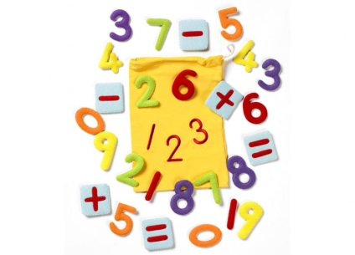

**Maths:**

Maths will include a higher emphasis on being able to explain mathematical processes as well as problem solve. We will begin by focusing on developing key number and calculation skills. This will include both mental and written methods. A key aspect of this will be ensuring that all pupils can rapidly recall their multiplication facts (up to 12 x 12) and extending this to decimals, eg 0.0089 x 100; 0.6 x 0.07; 7 x 7 x 7= .

Place Value – 10,000,000 to 1/1000 including decimals

Application of the four operations – Addition, subtraction, multiplication and division (including problem solving and reasoning)

Algebra

Measures – length, weight and capacity

Ratio and proportion

**How can I support my child?**

Encourage your child to learn/revise table facts – times tables tie into many aspects of maths! Random questions, tables songs in the car, asking questions such as, “If I buy 8 sweets at 7p each, how much have I spent?” will support the swift recall of tables. Give your child a number, such as 24, and ask them to generate as many ways as possible to make the number. Encourage them to impress you, for example, by using all four number operations, multi-step calculations, fractions, decimals and percentages.

**Writing units covered this term (not necessarily in this order):**

Poetry – including Shakespeare

Narrative stories – including writing related to Kensuke’s Kingdom

Recounts

Reports

Explanations

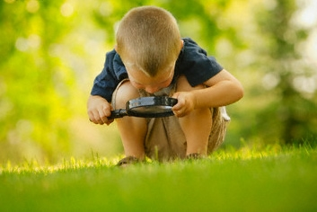

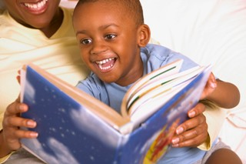

Science

In science this term we will be covering the uses of electricity and the way in which light works. Learning will include practical lessons and written application. We will also be studying animal classification where we will describe how living things are classified into broad groups according to common observable characteristics and based on similarities and differences, including micro-organisms, plants and animals

Other Areas

Some lessons are harder to integrate into the topic so these will be taught separately when this is the case. These include:

R.E.:

Aspects of Islam – focusing on the Five Pillars of Islam. There will also be an ongoing theme of Christianity including through worship both in school and Church.

P.E. and Games:

This will be taught by Ms Phillips and Miss Plant. P.E. lessons are on Wednesday and Thursday. Please ensure children have kits in school including sweatshirts and joggers as many of the lessons will be outside.

Computing:

Computing – including E-Safety – will be taught according to National Curriculum requirements.

Topic:

In Year 6, the curriculum recommends teaching of a significant world event which had an effect on Britain after 1066.

Our topic this term is World War II. This will be taught through a variety of curriculum areas including D&T, Art and Music.

School Journey

School journey to Kingswood, Runton Hall, will take place week commencing 21st October – further details to follow.

# 

# The Y6 team – Ms Phillips, Mrs Murdoch, Mrs Dave and Mrs Davey