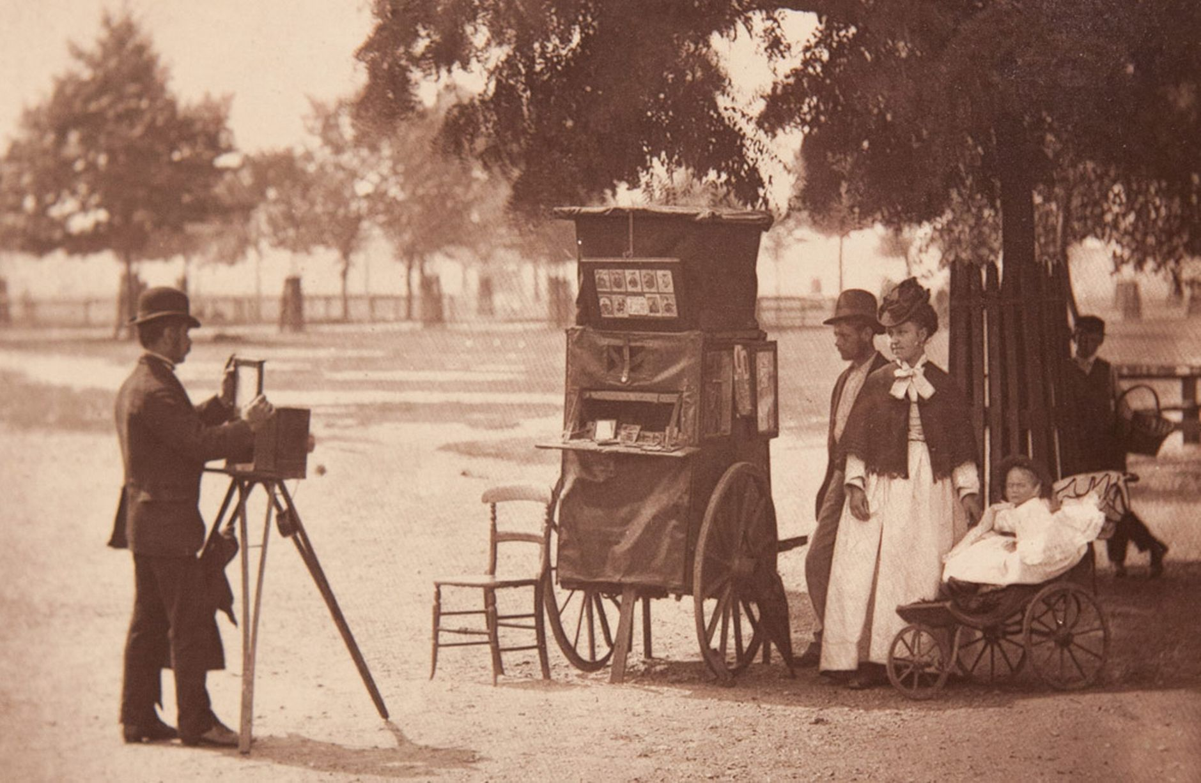
The Victorians
This homework is all about ‘The Victorian Times’.

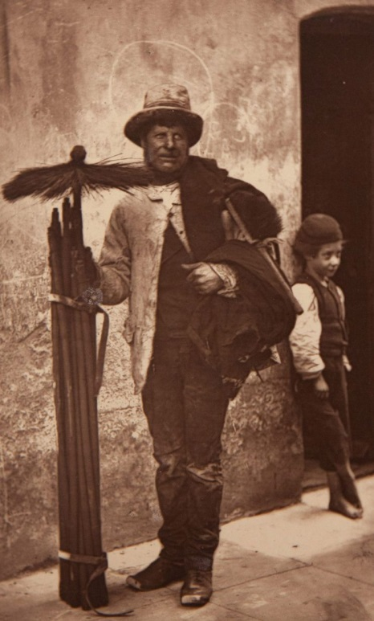
The Victorian Project
This homework project is all about The Victorians to link in with our History topic. The following pieces of work MUST be included in the project. Children can choose to extend their knowledge and learning by adding additional pieces of work to their project, however the tasks listed below are mandatory.
Mandatory tasks;
- Research and write about an aspect of Victorian life. You could focus on any of the following: Children at work; Children in coal mines; Children in factories; Children at school; Victorian schools; Children at play; Rich and poor families; Leisure; Toys and games; Famine and emigration.
- Design and make your own Victorian poster linked to one of the above areas of Victorian life.
- Write a comparison of the way children lived in the Victorian times compared to how children live now. Use the list above to help you.
- Write a diary entry as if you were a child living in Victorian times.
- Design a Victorian Christmas card.
- Design and make a Victorian Christmas decoration.
- Find a Christmas Carol that the Victorian Carol Singers would have sung then copy it out in your neatest, joined handwriting.

http://www.bbc.co.uk/schools/primaryhistory/victorian_britain/
http://www.bbc.co.uk/victorianchristmas/history.shtml
http://www.historic-uk.com/HistoryUK/HistoryofEngland/A-Victorian-Christmas/
The above websites have information, videos and picture to help you.
If you do not have internet access at home the children know they can attend the Key Stage 2 lunchtime homework club.
Have fun completing your project!
Mrs Eddington

